Deep Learning Strategies to Analyse Single-Cell Image Cytometry Data

BSc Computer Science

Luke Johnston (150352512)

Project Supervisor Jaume Bacardit

# Abstract

This project will describe the main workings of convolutional neural networks and discuss various state of the art models in this field. With various datasets and models from within open source deep learning frameworks, various experiments will be undertook to find the relationship between the number/selection of certain layers to the accuracy and running time of a model. From these results a Convolutional neural network will be built to analyse a dataset of single cell image cytometry data. These results will be compared to results achieved by a recent paper.

# Declaration

“I declare that this Project represents my own work unless otherwise stated”

# Acknowledgements

I would like to thank the efforts of my dissertation supervisor, Dr Jaume Bacardit for his invaluable help and guidance throughout the course of this project.

Contents

Abstract 2

Declaration 3

Acknowledgements 4

Chapter 1 – Introduction 9

1.1 Motivation and Rationale 9

1.2 Project Aims 9

1.3 Project Objectives 9

1.4 Project Schedule 10

1.4 Document Structure 11

Chapter 2 – Background research 12

2.1 Single Cell Analysis 13

2.2 Cell Cycle 15

2.3 Machine Learning 17

2.4 Deep Learning 19

2.5 Convolutional Neural Networks 20

2.5.1. Convolution 21

2.5.2. Activation 22

2.5.3. Pooling 23

2.5.4. Dropout 24

2.5.5. Fully connected (Softmax) 24

2.6. Influential CNN Architectures 24

2.6.1 AlexNet 25

2.6.2 ZF Net 26

2.6.3 VGG Net 27

2.6.4 GoogleNet 27

2.6.5 Microsoft’s ResNet 28

Chapter 3 – Project Methodologies 29

3.1. Approach to development 29

3.2. Training Technique 29

3.3. Evaluation Methods 30

Chapter 4 - System Design 31

4.1. Processing Single cell Cytometry Data 31

4.2. Convolutional Neural Network Design 32

4.3. Choosing Hyper-parameters 33

4.4. Types of hyper-parameters 34

4.5. Dealing with overfitting 35

4.6. Visualisation techniques 35

4.6.1. t-Distributed stochastic Neighbourhood embedding (t-SNE) 35

4.6.2. Dense/Convolutional Layer Visualization 36

Chapter 5 – System implementation 38

5.1. Technologies used 38

5.2. Usage of a GPU 38

5.3 Model architecture 39

5.4. Preparing the dataset 40

Chapter 6 - Testing and Evaluation 40

6.1. Iterative testing 40

6.2. t-SNE for unsupervised machine learning 45

6.3. Dense layer visualisation 46

Chapter 7 - Conclusion 48

References 49

Table of figures 5

Figure 1. Images produced from flow cytometry using a stain (PI) and an antibody (MPM2) [1] 13

Figure 2. Images produced from image cytometry [1] 14

Figure 3. t-SNE representation of the cell-cycle [1] 15

Figure 4. Channel 4 representation of cells in G2 (top) and Prophase (bottom) 16

Figure 5. Channel 4 representation of cells in Metaphase 16

17

Figure 6. Channel 4 representation of cells in Anaphase 17

Figure 7. Channel 4 representation of Cells in Telophase 17

Figure 8. Representation of a perceptron [8] 18

Figure 9. Shift invariance for recognizing cats [12] 20

Figure 10. Feature hierarchy for a CNN that classifies faces [14] 21

Figure 11. A two-dimensional convolution [16] 21

Figure 12. The sigmoid activation function [17] 22

Figure 13. The ReLU and leaky ReLU activation functions [18] 23

Figure 14. Diagram showing max pooling [20] 24

Figure 15. AlexNet Architecture [19] 25

Figure 16 – ZF Net Architecture [23] 27

Figure 17. VGG Net Architecture [24] 27

Figure 18. GoogleNet’s inception Module [25] 28

Figure 19. Diagram showing 10-fold validation [28] 30

Figure 20. Confusion Matrix example 31

Figure 21. Dataflow for pre-processing the dataset 32

Figure 22. Architecture for the networks base model 33

Figure 23 . t-SNE representation of the base model [33] 36

Figure 24. Filter representations of convolutional layers from VGG16 [34] 37

Figure 25. Filter representations of dense layers from VGG16 [34] 37

Figure 27. Architecture for the networks base model 39

Figure 28. Code to create the base model 39

Figure 29. Code to split the dataset 40

Figure 30. Architecture for the final model of this network 42

Figure 31. Confusion Matrices from iteration 9 43

Figure 32. The effect of image augmentation 44

Figure 33. Confusion Matrices from iteration 10 44

Figure 34. Confusion Matrix researchers achieved - Left [1] 45

Figure 31. Confusion Matrices from iteration 9 – right 45

Figure 35. t-SNE representation of the cell cycle bases on images from brightfield channel (ch3) [1] 46

Figure 36. Darkfield Dense layer visualizations of the cell cycle classes 46

Figure 37. Darkfield Dense layer visualizations of the cell cycle classes 47

# Chapter 1 – Introduction

## 1.1 Motivation and Rationale

In this project deep learning strategies will be developed to analyse single-cell image cytometry data. Image Flow Cytometry has been transformative for the field of biotechnology as it allows for the collection of data from individual cells rather than older methods which produced the average data values of the population. Image flow cytometry is extremely well suited for deep learning as it provides high sample numbers and images from several channels, that is, high dimensional, spatially correlated data. The deep learning architectures that will be developed will build upon current research and compare different architectures for classifying single cell image data.

One of the major challenges in biology is interpreting the increasing amount of information-rich and high-throughput single-cell data [1]. Biologists who are using the time consuming older machine learning methods are drastically missing out on faster analysis times from deep learning methods. These faster times analysis times would enable biologists faster analysis times and the ability to analyse on the go. Deep learning improves upon older machine learning methods as there is no need for any manual pre-processing or feature selection. As deep learning can extract features its able to reconstruct biological processes based on simple class labels alone. This is a drastic improvement upon machine learning and allows for a much faster analysis time.

## 1.2 Project Aims

The overall aim of this project is to create deep learning architectures that learn from image data and apply these architectures to high-quality data from local collaborators. The success of this project will be measured by the effectiveness of the architectures developed in comparison to already existing architectures.

## 1.3 Project Objectives

1. Familiarise myself with the data standards used within deep learning

By Familiarising myself with the data standards used for analysis I will be able to develop the architectures required for the single cell analysis. I will be completing an online course on deep learning from Coursera which will give me confidence in implementing a deep learning architecture.

1. Rebuild imaging flow cytometry analysis using cell profiler

Building on the first objective the second objective will allow me to gain some experience with working on an open source deep learning architecture. It will also provide me with some results from running the analysis which I will familiarise myself with so I can reproduce similar results myself. This has also enabled me to get to grips with some of the basic frameworks that will enable me to develop my architectures.

1. Develop Architectures that learn to classify cell stages

By developing upon source Deep learning architectures I will be able to apply them to high quality data from local contributors. The architectures will complete supervised learning with the test data set and learn to classify cell stages. I will then use a new data set to test how efficient the architectures are.

1. Develop Architectures that learn to classify novel cluster of cells with unsupervised machine learning

These architectures use a technique called dimensionality reduction to reduce the number of dimensions the data set so that it can be plotted over two-dimensions. These architectures group cells together based on similarities between the cells. With this clustering, any novel cells which don’t appear within the defined classed should be able to be identified. None of the older machine learning methods can do this.

1. Assess the different deep learning strategies used for analysing image data and compare performance

The final objective will be to assess and compare the different deep learning strategies that have been implemented to currently existing strategies. The performance will be assessed by looking at the accuracy and confusion matrices of both strategies. From this I will be able to see if the architectures I have developed have improved upon the existing architectures for single cell analysis.

## 1.4 Project Schedule

The timeline for this project is as follows:

|  |  |  |
| --- | --- | --- |
| Deadline | Task |  |
| 27th October 2017 | Ethics approval form | Complete |
| 3rd November 2017 | Project Presentation | Complete |
| 25th November 2017 | Familiarise with data standards and rebuild results(Objective 1 and 2) | Complete |
| 1st December 2017 | Project Proposal | Complete |
| 15th March 2018 | Develop Architecture to classify cell stages(Objective 3) | Complete |
| 25th March 2018 | Develop Architectures that use unsupervised machine learning to group cells(Objective 4) | Complete |
| 20th April 2018 | Project poster | Complete |
| 25th April 2018 | Asses Architectures (Objective 5) | Complete |
| 4th May 2018 | Project hand in | Complete |
| 9th May 2018 | Poster and Demonstration | Upcoming |

## 1.4 Document Structure

**Introduction**

The introduction presents the general overview of what is expected to be accomplished by the time this project is completed. The subsections are:

* Motivation and Rationale
* Project Aims
* Project Objectives
* Project Schedule

**Background Research**

This section aims to showcase the basic understanding of the cell cycle, along with the usage of single cell analysis in biology. The fundamental elements of convolutional neural networks are also described along with a showcase of award winning networks. This section consists of:

* Single Cell Analysis
* Cell Cycle
* Machine Learning
* Deep Learning
* Convolutional Neural Networks
* CNN Research

**Methodologies**

This chapter will cover the reasoning behind the choice of software development methodology. It will also outline and justify the choice of training techniques and evaluation methods used throughout this project. The subsections are:

* Approach To Development
* Training Techniques
* Evaluation Methods

**System Design**

The system design section will explain what hyper-parameters are and the effects that they have on the performance of a network. Various ways of dealing with overfitting are presented in this section. A range of visualisation techniques are also shown in this section. The subsections are:

* Processing Single Cell Cytometry Data
* Convolutional Neural Network Design
* Choosing Hyper-Parameters
* Types of Hyper-Parameters
* Dealing with Overfitting
* Visualisation Techniques

**System implementation**

This section shows the wide range of technologies used for this project along with justifications as to why they were used. This section also shows how the data is pre-processed before it enters the network. This section includes:

* Technologies used
* Model Architecture
* Preparing the Dataset

**Testing and Evaluation**

This section will showcase the performances of each iteration of the convolutional neural network used along with various visualisations of the network. The subsections are:

* Iterative Testing
* t-SNE for unsupervised machine learning
* Dense Layer Visualisation
* Convolutional Layer Visualisation

**Conclusion**

This section will summarise the project and evaluate whether this project was a success based on the original aims and objectives.

# Chapter 2 – Background research

This section contains the background research carried out for this project. It’s split into two key parts. The first half of this section contains research which shows the basic description of the cell cycle and the current usage of single cell analysis and the ways that deep learning can be used to classify huge datasets. This first half will also contain a brief overview of machine/deep learning and will also go into detail about the basic concepts of convolutional neural networks. This will be useful to gain some basic understanding of the key components needed for this project to be successful.

The second part of this section contains research on several existing neural networks and the certain aspects or elements which researchers included to make them perform exceedingly well. Information from these highly performing networks will be taken into consideration when designing and implementing a network later on in this project.

## 2.1 Single Cell Analysis

Cytometry is the science behind the measurement of cells. There are many measurements that can be taken such as the cell count, cell shape, DNA content or the cell cycle phase, which this project aims to classify. There are several different techniques used in cytometry; Flow Cytometry, Mass cytometry and Image cytometry.

Flow Cytometry tends to use fluorescent stains and antibodies to label the cellular components [3].With antibodies, cells are labelled by attaching specific antibodies that attach to a target protein and emit a fluorescent light. With staining, the cells uptake the dye in specific positions based upon the dye used and emit a fluorescent light. These cells are then passed through a laser and the fluorescent light is detected. The fluorescence can determine certain features depending on what antibodies are used. One issue with staining however is that some stains can damage the cellular DNA. See figure 1 for an exemplification of the images flow cytometry produces.

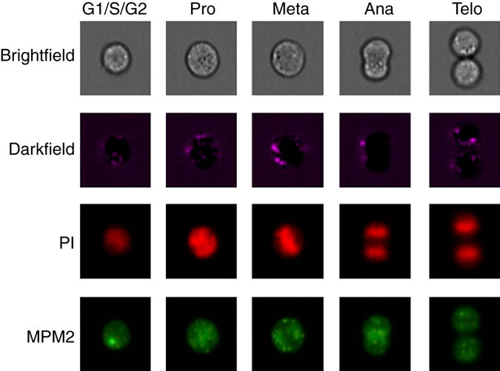

****Figure 1. Images produced from flow cytometry using a stain (PI) and an antibody (MPM2) [1]****

Mass cytometry is a variation of flow cytometry in which heavy metal ions are used to label cells rather than antibodies. Image cytometry is the oldest type of cytometry and uses optical microscopy to image cells. Figure 2 shows two different channels that can be used in image cytometry.

****Figure 2. Images produced from image cytometry [1]****

A major goal for biologists has been to make as make as many measurements on as many cells as possible with the ultimate goal of identifying every cell and transition states as possible [2]. This has often been referred to as the “parameter race” by researchers. From learning every cell type and transition stage biologists are able to gain a further understanding into biological processes that are misunderstood or undiscovered.

Imaging flow cytometry has played a huge part in this “parameter race”. Imaging flow cytometry is essential for analysing cells as it allows for measurements to be taken in rapid succession, allowing for analysis of cells sort lasted transition stages. Imaging cytometry allows for a large amount of parameter rich data to be collected. This is extremely well suited to deep learning as image flow cytometry provides very high sample numbers and data that is highly dimensional.

Imaging flow cytometry also takes into account the brightfield and darkfield images of the samples. These channels are enough to classify the different cell stages without the use of stains or antibodies. If image cytometry was solely used there is no need to use stains or antibodies. There are many benefits from avoiding fluorescent stains. As stains are costly, one benefit to avoiding them is a reduced cost. Time is also saved as there is no need to apply the stains. Perhaps the greatest benefit is the ability to classify live cells. The main benefit from avoiding antibodies is also a reduced cost, as antibodies are expensive to design and produce. However one drawback from not using flow cytometry is that without flow cytometry less information is obtained from the samples.

With imaging flow cytometry, a high number of cells are able to be collected in short periods of time. However with the increasing amount of single cell data that biologists are producing with the rapid development of imaging technology, data analysts are struggling to analyse/classify all this data. It’s often highly subjective and often there are features that humans cannot perhaps see [4] which often leads to errors in classification. Even highly skilled and experienced data analysts can struggle with such a large dataset and so there is a need for automation. To deal with such an issue a program called the Cell profiler was created to aid with the classification of cells. The cell profiler is an open source cell image analysis software. It’s used to analyse and extract features from the images from the IFC. After this the dataset is then ready to be classified using deep learning

In Live cell imaging the major problem to classify cells is image segmentation [5]. Image segmentation is required to separate the live image of multiple cells into images of single cells. It can take several hours of manual labelling for data analysts, whereas convolutional neural networks can not only drastically decrease the segmentation time but they can also improve upon the accuracy. When compared to older machine learning methods deep learning has been shown to increases the rate of classification to allow for on-the-fly analysis. Deep learning has been shown to increase the rate of analysis 100-fold, from 10 cells per second to 1000 cells per second [1] This is largely due to the fact that with deep learning there is no need to manual define features within the cell. Therefore this means that deep learning will be able to decrease the costs of analysis as the amount of work of data analysts will be drastically reduced.

As with convolutional neural networks there are neurons that learn the different features that each cell type in the population of cells have. The activations in the final layer of the CNN are able to show how similar cells are to each other. This is supervised learning. Another way to visualise populations are with unsupervised learning. t-SNE is a type of unsupervised learning, which groups cells that are similar together. With t-SNE it’s then possible to plot the cells from the population and we can see how they are organised as a cell cycle, by comparing the similarities between each cell cycle stage. Considering that with t-SNE, the network wasn’t given any information about the cell cycle it’s pretty remarkable that it was able to correctly predict the cycle. Figure 3 shows the t-SNE representation of the cell-cycle.

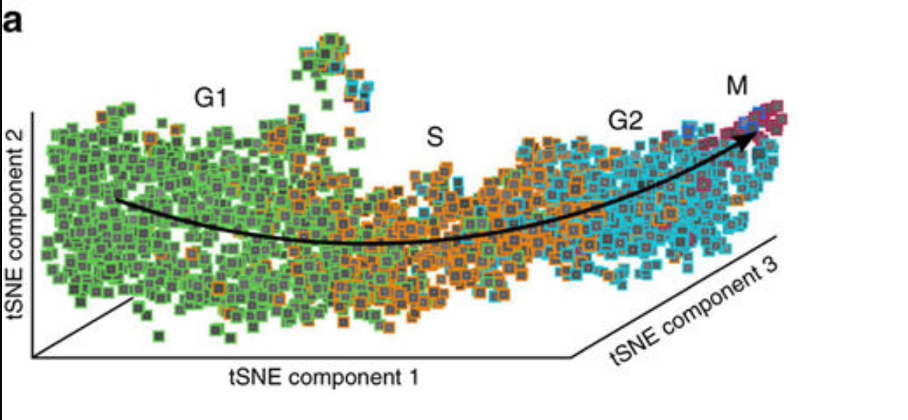

****Figure 3. t-SNE representation of the cell-cycle [1]****

## 2.2 Cell Cycle

The network that is to be implemented will classify cell cycle stages. The cell cycle is broken into a resting state, interphase and cell division. Interphase consists of G1, S and G2. Cell division or Mitosis is broken down into four parts: prophase, metaphase, anaphase and telophase. Interphase is the longest state of the cell cycle. In interphase the cell obtains the nutrients / materials and starts DNA replication. The purpose of this stage is to prepare the cell for cell division or mitosis. The interphase stages are perhaps the most difficult stages to distinguish with imaging flow cytometry as they all look very similar to the human eye. In Mitosis, the cell stops its growth and focuses on the division of itself into two daughter cells. The stages in Mitosis, are somewhat distinguishable and some can be classified with the human eye.

In prophase chromatin (which is the material chromosomes are composed of) condenses. Figure 4 shows cells from ch4, which is the channel which uses a PI stain. The differences between G2 and prophase can be seen as the cells in prophase are brighter, indicating the condensed chromatin.

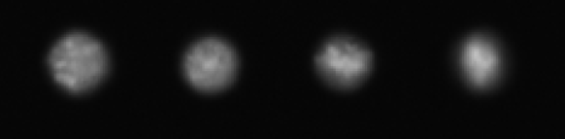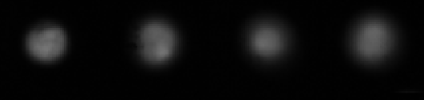

****Figure 4. Channel 4 representation of cells in G2 (top) and Prophase (bottom)****

In metaphase chromosomes align at the equator of the cell. Figure 5 shows metaphase cells from ch4. The dense collection of chromosomes along the equator of the cell can be seen.

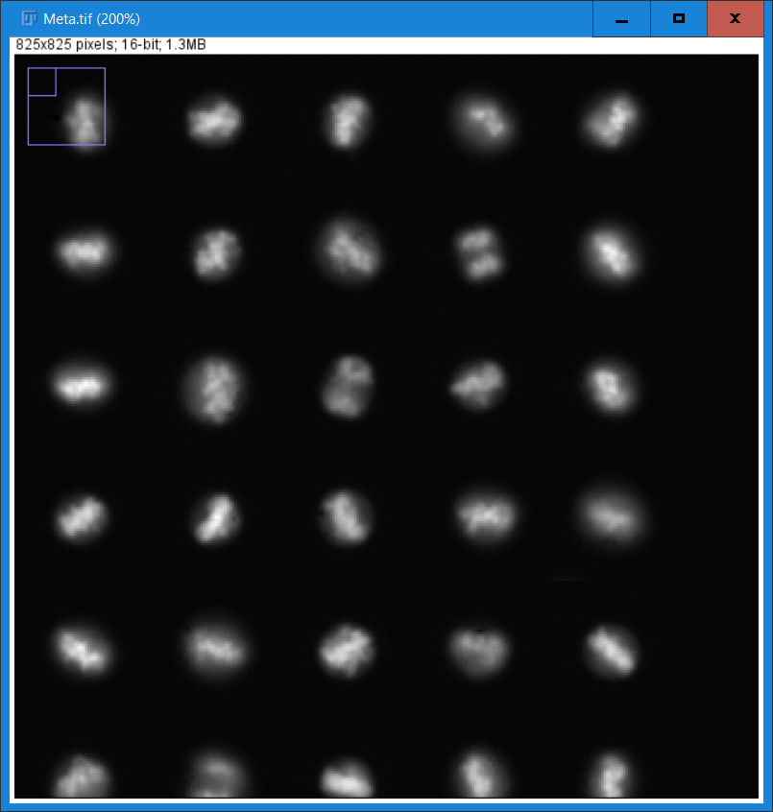

****Figure 5. Channel 4 representation of cells in Metaphase****

In Anaphase, chromosomes are split into daughter chromatids and move to opposite poles of the cell. Figure 6 shows Anaphase cells from ch4. Chromatids can be seen at opposite sides of the cell.

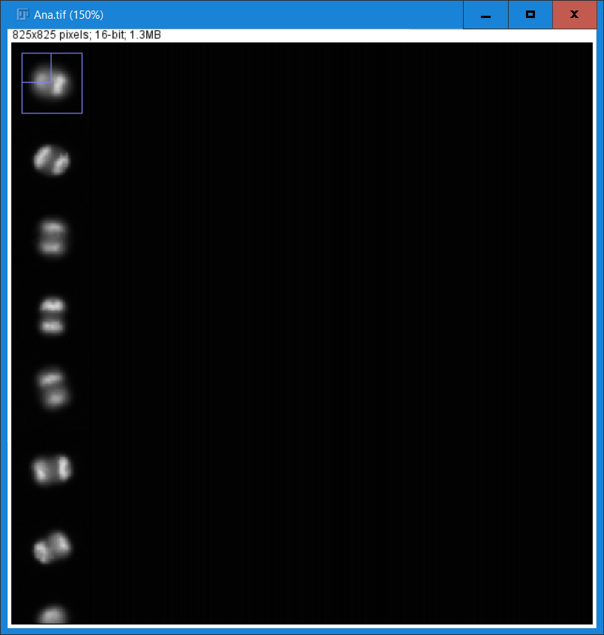

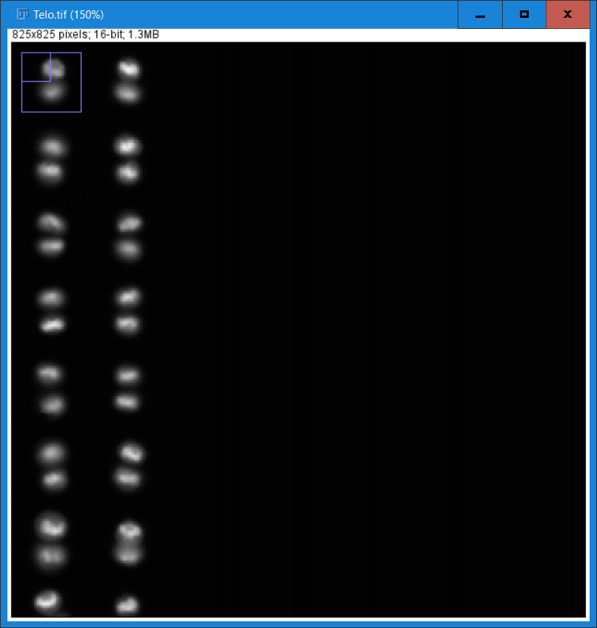

****Figure 6. Channel 4 representation of cells in Anaphase****

In Telophase chromosomes are surrounded by nuclear envelope and form nuclei in both the daughter cells. Figure 7 shows Telophase cells from ch4. The cells nuclei has formed and the cell can be seen almost separated. However the cells are still connected and won’t separate until cytokinesis.

****Figure 7. Channel 4 representation of Cells in Telophase****

## 2.3 Machine Learning

Machine learning – ‘How to construct programs that learn from experience’ [6]

Machine learning is the concept of trying to make machines imitate and adapt human like behaviours, allowing them to “learn” a dataset without being explicitly programmed to handle that dataset. As there has been no explicitly programmed behaviour the machines have to learn from experience.

Google have been using machine learning in a number of ways, for example in Gmail, machine learning is used to categorize email importance and to recognise spam, it’s also used for google search to predict what is being typed and then it provides useful suggestions. The machine learning models learn from previous user data such as previous emails, past searches. As more data is added the model will improve and its error rate will decrease.

When it comes to solving problems, machine learning can solve two types, classification and regression. Classification problems are where the machine is trying to classify a dataset which already contain the class labels. An example of a binary classification problem is if a network was created specifically to classify images of dogs, the network would provide a yes or no result. An example of a multiclass classification would be a network which was created to identify images of multiple animals and would provide a specific animal as the classification. Regression on the other hand is when a network is created to predict a continuous value, for example if a network was created specifically to predict house price values. The network would provide a continuous value. In regression the network is trying to find the correlation between multiple inputs.

When training a network its necessary to split the dataset into two. The dataset is split into a training set and a test set. The training set is used to generate a model and the test set is used to validate the model. If when testing the model the network produces an accuracy that is higher in the training set than the test set, overfitting has occurred. Overfitting is when the network learns to classify the training set well, however it does not generalize the dataset well, meaning that it learns to recognize specific images rather than high level features. This means that when the network is fed new data in the form of a test set it will classify it poorly.

There are two types of machine learning, supervised and unsupervised. Supervised machine learning is where the network is trained on a pre-defined dataset (training set) and is tested on a pre-defined dataset (test set). The network attempts to predict the classes of each instance from the dataset. For example a network which attempts to classify a dataset of hand written digits. Unsupervised machine learning however is where the network is given a dataset and it’s trained to find patterns and relationships within the data. For example if the dataset of digits had no labels, the network would learn to cluster the similar digits based on their similarities.

Neural networks are an extension of deep learning and are a virtual network, which is inspired by the human brain [7]. Neural networks are used to classify and cluster data as described above.

An artificial neural network is made up of a series of connected units. These units are simplified form of neurons found in the brain. Perceptron’s are perhaps the simplest form of artificial neurone and can make up simple neural networks. A perceptron takes several binary inputs and outputs a single binary output. Because of this a perceptron can only solve linear problems. Figure 8 shows an example of a perceptron.

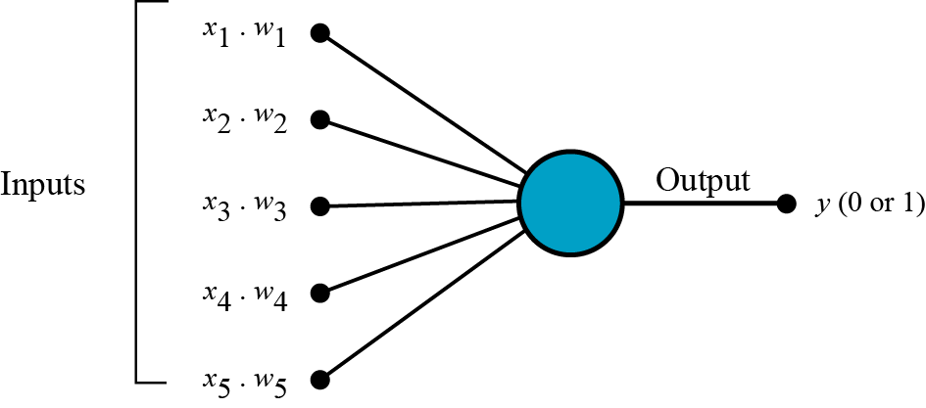 Figure 8. Representation of a perceptron [8]

Perceptron’s make use of activation functions which determine the strength of the output signal. Historically the value a perceptron produced was based on a step activation function. The step activation function produces binary output as it outputs either a 0 or a 1 depending on if the sum of inputs is greater than the pre-defined threshold value. Other activation functions can be used such as the sigmoid function. This outputs a value between 0 and 1.

Multi-Layer perceptron’s (MLP) are made up of layers of perceptron’s and have been shown to solve non-linear problems. The links between each perceptron are called weights. These weights are what influence training on the network. Weights refer to the importance an input has on a perceptron’s output. MLPs with a single hidden layer are said to be able to learn any continuous function also any function that can be approximated by continuous functions by the universal approximation theorem [9]

MLPs are trained with a form of supervised training called backpropagation. Backpropagation is a form of gradient descent which is a popular optimization technique used to train a network. Backpropagation consists of two passes; the forward pass and a backwards pass. In the forward pass, the input is passed through the network until it reaches the final output layer. The output produced is then compared to the corresponding label for that input using a loss function. The loss function calculates the difference between the actual output and the desired output. In the backwards pass this loss function is passed back down through the network, giving each perceptron a loss value. The gradient is then calculated for each perceptron by taking its loss value and differentiating it with the perceptron’s weight. The gradient is then passed into an optimisation function. The optimisation function is used to update the values of weights in the network. Its goal is to minimise the networks loss function.

## 2.4 Deep Learning

Deep learning is a fast ricing force in the field of artificial intelligence, which is a specialised form of deep learning. It is a reinvention of artificial neural networks which have an increase in layers to regular neural networks. Deep learning networks are said to have a feature hierarchy. A feature hierarchy organises itself into levels of features. With higher level features being defined in terms of lower level features. [10]

Deep learning models are usually trained with larger datasets compared to traditional Machine learning neural networks. Traditional MLPs don’t scale well with large datasets, and tend to converge to an optimum performance early. The performance of Deep learning networks however only improve with more data. This is because deep learning networks contain more layer than older MLPs. This increases the number of connections the network has, meaning that the network can recognise more complex features. The bigger the dataset is, the more features the network can learn to recognise.

Deep learning has shown a huge capacity for generating high order patterns from data. It has shown state of the art competence across many tasks such as image recognition, learning to play games, text mining and many more. In the field of gaming, AlphaGo Zero became the first computer program to defeat a world champion. It was used in 2016 to beat the world champion Go Zero player, Lee Sedol. AlphaGo Zero was trained by playing games against itself and from over 4.9 million games played, learned to predict moves and use novel strategies, which have provided new insights into the game [11].

## 2.5 Convolutional Neural Networks

Convolutional neural network are a type of neural network which are used for analysing images. CNNs have been hugely influential in the world of computer vision. Previously before CNNs were invented computer struggled at image classification tasks. Existing algorithms could recognise basic patterns but couldn’t form abstract features from these patterns. One major issue was that the basic algorithms struggled if the input data was flipped or skewed off centre. CNNs implement a feature called shift invariant, allowing for features to be detected in all locations of an image. Figure 9 shows an example of shift invariance.

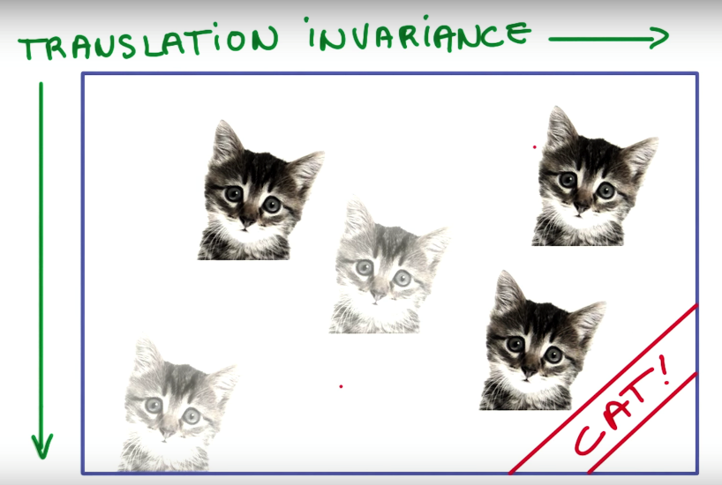

****Figure 9. Shift invariance for recognizing cats [12]****

CNNs were originally inspired by the visual cortex of a cat [13]. From their experiments, Hubel and Wiesel’s discovered that the visual cortex’s contained two basic types of neurons, simple cells and complex cells. The simple cells respond to small shapes such as lines. The complex cells respond to higher level features and patterns and help to build a full visual picture. Hubel and Wiesel’s work helped design how a convolutional neural network works, in that each filter in the network is specialised to stimulate when a certain low level feature such as a horizontal or vertical line is detected. And as an organised network, can recognise higher level features. Keras-vis is a toolkit for visualising the filters from each layer in a CNN. Figure 10 shows an example of how a feature hierarchy is structured in a CNN.

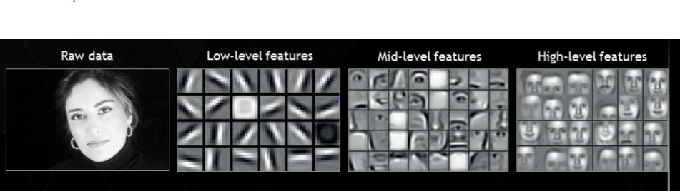

****Figure 10. Feature hierarchy for a CNN that classifies faces [14]****

Deemed to be the most renowned company using Deep learning by experts, Google have created a service called Google Cloud Vision. Google Cloud Vision uses CNNs to analyse user’s images. It can classify images into thousands of categories and can detect individual objects within images. GIPHY, which is an online database of millions of GIFs uses Googles Cloud vision to analyse their collection. After analysis, GIFs are labelled with meta-information, enabling GIPHY’s users to search for GIFs based on phrases, movie lines or lyrics etc. [15].

### 2.5.1. Convolution

CNNs are made up of many layers, each layer adds to the complexity of the model, allowing it to understand more complex features. The convolutional layer is usually the first layer used. It involves a convolution around the input. The process of convolution is explained below.

A filter is a matrix which is smaller in size than the image matrix. The filters in the convolutional layer stride around the image and performs matrix multiplications between itself and the image matrix. The resulting matrix is most commonly called feature map, however people also refer to them as an activation map. Figure 11 shows a filter being applied to an image matrix and the resulting feature map.

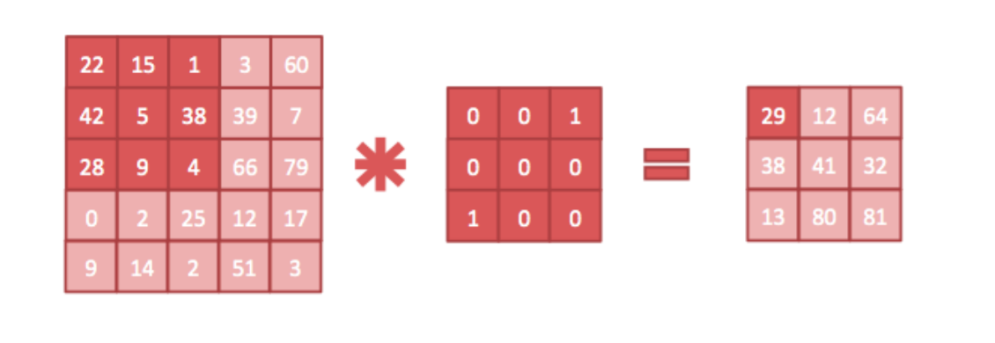

****Figure 11. A two-dimensional convolution [16]****

There is a term called parameter sharing, which is used within convolution layers which help reduce the number of parameter within a model. Reducing the number of parameters reduces the computational difficulty of the model, which in turn decreases the running time. Parameter sharing involves replicating each filter across the entire image matrix, giving the network the ability to recognise a given feature anywhere on the image. Parameter sharing contributes to shift invariance which is shown in figure 9.

Parameter sharing assumes that one filter at say position (x, y) in the image matrix, which recognizes feature z will also be able to recognize feature z at (x2, y2). This would be of use for example if the feature was to recognise sharp curves, which in theory should be able to appear anywhere in an image. However it’s often best to relax parameter sharing if features only appear in a certain area of an image. For example if the network is trained to recognise facial features from a dataset of headshots. The facial features such as a mouth will always be in a similar place on the image and so there is no need to search for it in a different position as it would be a waste of computing resources.

### 2.5.2. Activation

In the convolutional layers there is some normalisation (activation function) applied to the data. Activation functions decide if a neurone should fire or not. Originally functions such as sigmoid were used. The sigmoid function is shown in figure 12. The sigmoid can be inferred as the firing rate of a neurone with 0 meaning the neurone doesn’t fire and 1 meaning the neurone is fully saturated when firing. However sigmoid functions are prone to the vanishing gradient problem. This is caused when training the network with backpropagation. With sigmoid functions the gradients tend to decrease and get smaller when moving back through the network, effectively preventing some weights from changing in value. Because of this the deeper layers in the network struggle to learn whereas the later layers can learn. This is a huge issue as the early layers are vital for learning the most simplistic features from an image and because a CNN is hierarchical, if the early layers incorrectly learn these features then every layer further down the network will not be able to learn any complex features.

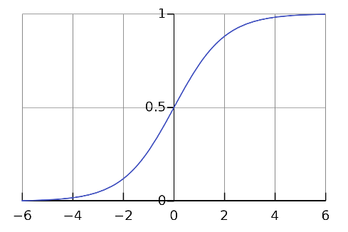

****Figure 12. The sigmoid activation function [17]****

The most commonly used activation function is ReLU. ReLU is shown in figure 13.

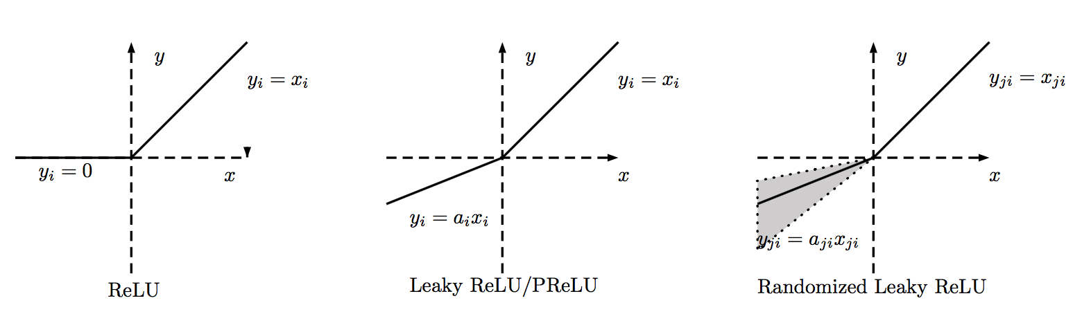

****Figure 13. The ReLU and leaky ReLU activation functions [18]****

ReLU is defined as:

F(x) = max (0, x)

Where x is the input to a neuron.

The output of a ReLU function is either the input, if that input is a positive number, or 0 if the input is negative. Because of this it introduces non linearity to the network meaning that it can solve nonlinear problems. Using ReLU also alleviates the issue of the vanishing gradient problems, as the gradient is either 0 or 1, meaning that the gradient never saturates. One issue with ReLU however is that neurons can become fragile during training and dye. If the gradient is too high during a backwards pass it could cause the weights to irreversibly update in a way that means the neuron will only output 0 for any given weight. Because of this the neuron will have no further impact on the network. There is another form of the ReLU function called a Leaky ReLU. Leaky ReLU is shown in figure 13. Leaky ReLU’s attempt to fix the dying ReLU problem. Instead of negative values equalling 0 when negative, the leaky ReLU has a tiny gradient scope, meaning that it will return a small negative value. Because of this, the neurone will never have a 0 gradient value, meaning that it can recover from a gradient that was too high. Compared to other activation functions such as tanH or Sigmoid, ReLU is faster to train on. This is because ReLU is an inexpensive operation as compared to the other activation functions. Researchers found that when using ReLU in place of tanH when training a four layer CNN on the CIFAR-10 dataset, the CNN trained six times faster [19].

### 2.5.3. Pooling

A pooling layer is usually placed after convolutional layers to down sample the data. Pooling works by dividing the filter up into smaller sections and selecting the most important part of each section to pass onto the next layer. It helps to reduce complexity meaning that the network can learn more abstract features. The most commonly used pooling is max. Max pooling takes the max value from each segment of the filter and passes it onto the next layer. The most common size is a matrix size of 2x2 and a stride of 2. This would discard three quarters of the data, meaning that the network will have less to learn and so will learn more extract features. Generally adjacent units don’t overlap. However overlapping pooling can be used, which uses a stride smaller than the width of a segment. This has been shown to reduce error rates and reduce overfitting [19]. Max pooling is shown in figure 14.



****Figure 14. Diagram showing max pooling [20]****

### 2.5.4. Dropout

Dropout is a form of regularisation and works by turning random neurons weights to 0. By doing this it prevent neurons from co-adapting in which a filter is only useful in the context of other specific filters [21]. This forces the network to learn new representations of the data, meaning filters learn to detect more generalised features that will be of use when classifying the dataset. This helps prevent overfitting as it prevents the network getting too specified for a certain dataset.

### 2.5.5. Fully connected (Softmax)

One or more fully connected layers are placed at the end of a network. The input for this layer are usually the filters from the final convolutional layer. It uses these high level features to classify each image by outputting probabilities for each class the network is trying to classify. The argmax function is then used on these probabilities to calculate the class with the highest probability. The argmax function simply returns the index of the largest value from the array of probabilities. The class corresponding to this array index would then be the class the network predicts.

## 2.6. Influential CNN Architectures

ImageNet Is a dataset of over 15 million images, with around 22000 classes. The images were collected by participants of amazons Mechanical Turk programme. ImageNet was envisioned when researchers from Princeton University realised that a key part to improving AI, wasn’t improving the algorithms, but increasing the size of the dataset [22]. With limited examples, the data only reflects a small part of the world. The main problem with a small dataset when it comes to image recognition is that the algorithm only learns to recognise those specific examples. This means that other factors, such as lighting conditions or the distance the object it is away from the camera etc., can play an effect on if the algorithm can recognise the object. By increasing the size of the dataset the algorithm will have more examples to learn from and should be able to gain a better overview of what to recognise for each object, meaning external factors have less of an impact on classification. Its creators hoped that this huge dataset will be useful as a training resource for the research community. It quickly became a benchmark dataset for AI when researchers are improving/creating new image recognition algorithms. ImageNet annually host an ImageNet Large Scale Visual Recognition Challenge (ILSVRC), which uses a shortened list of 100 images from 1000 categories to see which participants can classify the dataset with the highest accuracy.

### 2.6.1 AlexNet

Researchers from the University of Toronto created a convolutional neural network which was used to classify the shortened ImageNet dataset for use in the ILSVRC-2012 competition and it achieved a winning test error rate of 15.3% [19]. The network was called AlexNet.

AlexNet was the only deep learning network in that year’s competition and beat the other competitors by 10.8%. From such an impressive result against the more traditional AI algorithms, AlexNet could have been the network that inspired the huge boost into deep learning research that followed this competition. Due to the huge computational requirement from training a CNN on a huge dataset, the researchers used GPUs to improve performance and reduce the running time. With two GTX 580 GPUs it took six days to train. The architecture for AlexNet is shown in figure 15.

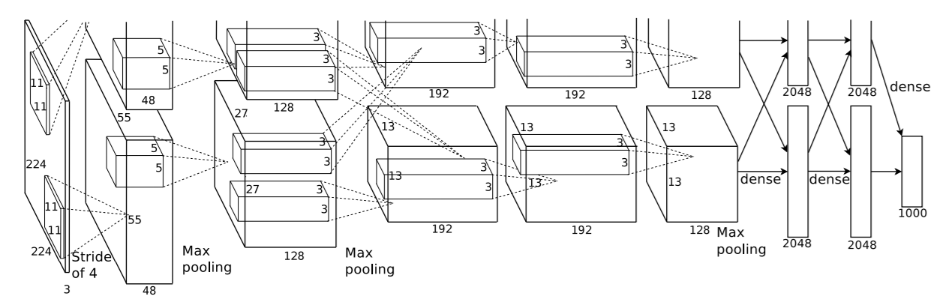

****Figure 15. AlexNet Architecture [19]****

AlexNet has eight layers, containing 5 Convolutional layers and 3 fully connected layers. The first and second convolutional layer are each followed by a max pooling layer. Three convolutional layers follow with a max pooling afterwards. The output from this layer is then passed into three dense layers. The network consists of 60 million parameters.

Due to ImageNet being such a large dataset the network is likely to overfit. To reduce overfitting there are several methods that the researchers implemented. One of which being a fairly recently developed regularisation method at the time called Dropout and the other being a commonly used method called data augmentation.

Dropout involves resetting random neurons weight to 0. As the network learns the neurons develop a co-dependency between each other. By settings the values to 0, the network is forced learn more robust features which in turn help increase the networks ability to correctly classify images. A drawback to dropout however is that it can increase training, with networks taking 2-3 times longer than a network without dropout [21]. However this trade off in accuracy over training time is certainly worth it if the network is learning to classify a dataset that is likely to overfit.

Data augmentation is a popular method used and involves transforming images in a number of ways. Perhaps the most frequently used methods are horizontal reflections and cropping. By augmenting the dataset, the number of samples in the dataset are increased. This would be especially important if a network was trying to classify a dataset where one or more classes are underpopulated. By doing this the network has more samples to train on meaning that the network should be able to learn the higher level patterns present from underrepresented classes and classify these classes to a high accuracy on the validation set.

### 2.6.2 ZF Net

ZF Net was the competition winner in 2013 and made some minute changes to AlexNet. It was designed by researchers from New York University. The researchers make a vital argument that the development of these models are due to trial and error and it’s near impossible to suggest an architecture that will initially perform well on a dataset [23]. Because of this they decided to implement a method to visualise the features maps of the network to gain further understanding on how they work. They called this a Deconvolutional network, or DeconvNet for short.

The DeconvNet works the same way a convolutional network works, but in reverse. Rather than mapping pixels to features, features are being mapped to pixels. The DeconvNet is attached to the ConvNet. The ConvNet is passed an image to see what filters it activates. When examining a single feature, the activations of that singular feature would be kept, however all other features activations in the same layer are set to zero. This way it’s possible to see what lower level features directly impact the higher level feature selected. The architecture for ZF Net is shown in figure 16

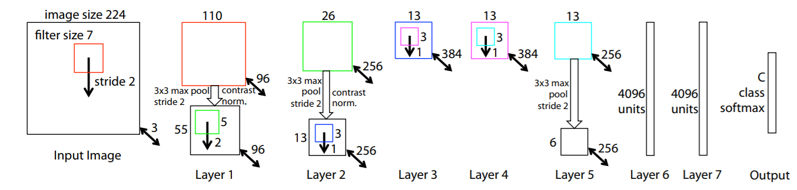

****Figure 16 – ZF Net Architecture [23]****

The architecture is almost identical to AlexNet, however a filter of size 7x7 was used rather than 11x11 as used in AlexNet. A smaller stride value of 2 was also used. These values where used as by using a smaller filter and stride the network will retain more information from the image. Considering that this is the first layer in the network, the network will be able to learn more detailed features. The network was trained on a GTX 580 GPU and took a total of twelve days to train.

### 2.6.3 VGG Net

VGG Net is another network implemented for the ILSVRC competition in 2014 which came close to winning with an error rate of 7.3%. It was designed by researchers at the University of Oxford. It implements a simple but deep network and shows that the networks depth is an important part to achieving good results. The best performing variation consisted of 16 layers. 13 of these layers were convolutional and all used 3x3 filters, with a stride of 1. They used a combination of these layers before applying max pooling. Figure 17 shows the architecture for VGG Net.

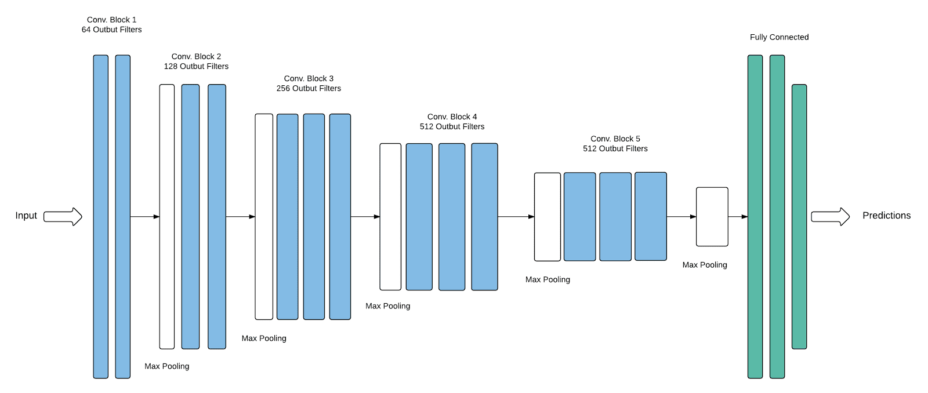

****Figure 17. VGG Net Architecture [24]****

The reasoning behind using smaller filter sizes is that with convolutional layers placed together have an effective receptive field of 5 x 5. Three convolutional layers then have an effective receptive field of 7 x 7. This means that the network can imitate larger filters and also keep the benefits that smaller filters provide such as retaining more information from the image. The network was trained on 4 Nvidia Titan Black GPUs for around two and a half weeks.

### 2.6.4 GoogleNet

The winner of the 2014 ILSCVC was in fact GoogleNet with an error rate of 6.7%. Despite the idea that a simpler network was more practical and efficient, GoogleNet created a more complex network with inception modules [25]. Basic CNNs are sequential in that they perform one operation at one time. These modules allows the network to perform the convolution operation and the pooling operation at the same time, in parallel. This may produce a large amount of parameters, however the researchers used multiple methods to decrease these to an impressively low amount. Even lower than the amount of parameters used in AlexNet which has over 10 times fewer layers. One method used to reduce the number of parameters was to concatenate 1 x 1 convolutional layers with the previous inception modules output when connecting inception modules. This is used for dimensionality reduction. Figure 18 shows an inception module with this dimension reduction. The network is still very deep, with a total of 9 inception modules and a total of over 100 layers. It took around one week to train with a few high end GPUs.

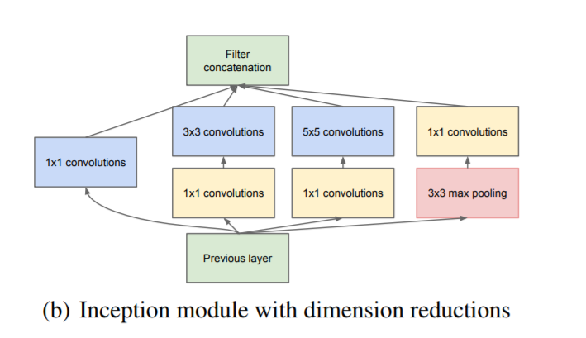

****Figure 18. GoogleNet’s inception Module [25]****

### 2.6.5 Microsoft’s ResNet

The winner of the 2015 ILSVRC was Microsoft’s ResNet with an error rate of 3.5%. ResNet was designed by researchers from Microsoft Research Asia. This beats the general human error rate which is reported to be around 5.1% [26]. The researchers expanded on the idea that GoogleNet presented that having a deeper network was a crucial factor in the networks performance. ResNet uses a total of 152 layers split into residual blocks.

Microsoft’s ResNet was the best CNN at the time of this competition, however the winner of 2016 ILSVRC, CUImage managed to improve upon it and achieve an error rate of 2.991%. CUImage achieved this result be using a combination of pre-trained models from the previous year’s winners. In 2017, just over three quarters of teams achieved an error rate of less than 5%. Because of this it appears that the ImageNet competition is reaching the point of diminishing returns. Some researchers speculate that the remaining error rate may be down to mislabelling by the human participants. For example some images may contain multiple images [27]. This means that participants may be unsure on what label to apply to the image. Some participants may also be unsure on a label, for example a specific species of cat. Some species are very similar and so may be misinterpreted by participants. Perhaps using a larger sub sample of classes would introduce a more complex problem for future competitions, and introduce newer architectures that can classify a wider range of images.

# Chapter 3 – Project Methodologies

This section contains the design and implementation methods that were used in development of this convolutional neural network with an explanation to why they were used. It also contains the choice of technologies used throughout the project along with the reasoning behind choosing such technologies. It will also show what methods will be used to train and evaluate the network.

## 3.1. Approach to development

An agile software development approach was chosen for this project as Deep learning involves lots of hyper-parameter tweaking. A base model is usually defined at the start of testing and then changes are iteratively made to the model. These changes are then kept if they improve upon the previous iteration or discarded if they worsen the mode. The changes made to the model are often down to trial and error as the inner workings of neural networks are not well understood.

Trello was used to aid the development of this project. Trello is a web-based project planning application which can be used to implement the agile software development methodology. A Trello board consists of three main sections: To Do, Doing and Done. These names are self-explanatory and enabled personal and official deadlines to be efficiently managed. One feature from Trello which provided to be of use was the ability to label tasks by priority. This enabled tasks of higher priority to be completed before tackling lower priority tasks.

## 3.2. Training Technique

Its best practice to split the dataset into two parts, the training and test dataset. The training set trains the model and the test set is used to calculate the effectiveness of the model. The split between the original dataset is commonly around 80% for the training set and the remaining 20% for the test set. This helps to prevent overfitting. If the network is fed the same data it will learn to classify that set of data. Granted it would produce an excellent result for that dataset, however it would struggle to classify a new dataset.

Another common approach when preparing the dataset is to shuffle it before passing it into the dataset. Without shuffling, the dataset will be ordered by its classes and so when the network is fed batches of data the first few batches will be of the same class. This means that the network will initially only learn to classify that single class and when its later fed batches of other classes may struggle to classify them.

Another way to train and validate a model is with a cross validator called k-fold. K-fold validation splits the original dataset into k subsections. Of the k subsections a single subsection is used for the test dataset and the remaining k-1 subsections are used for training the network. This process is then repeated k times, until every subsection is used as the test dataset. The results are then combined and divided by k to get the average value. Stratified K-fold is a common variety of k-fold which ensures that each fold contains approximately the same percentage of samples of each class as found in the full dataset. Figure 19 shows k-fold validation

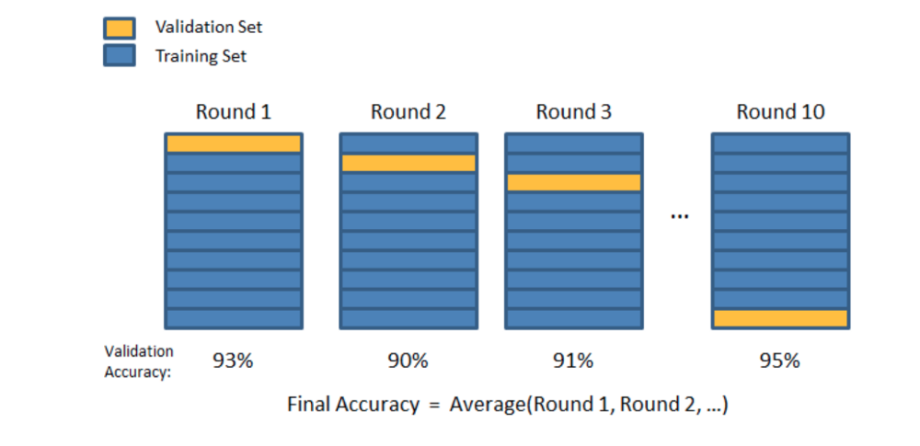

****Figure 19. Diagram showing 10-fold validation [28]****

## 3.3. Evaluation Methods

When evaluating the network towards the end of this paper, there are several results to take into account when evaluating the performance of the network. Firstly, perhaps the most important result would be the overall accuracy and the loss of the network. This gives a great overview of how the network performs, however what it doesn’t show is what the network is good at predicting and what the network is bad at predicting. A confusion matrix is a matrices that’s often used to evaluate a networks performance. Figure 20 shows a hypothetical confusion matrix in aid to explain its terminology. The number of instances in this example is 100.

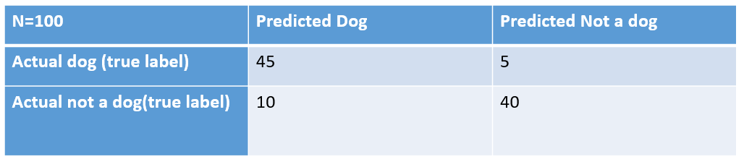****Figure 20. Confusion Matrix example****

The four key terminology for confusion matrices are: true positives, true negatives, false positives and false negatives.

True positives are cases where the network correctly classified an instance, for example where it predicted a dog when the instance was actually a dog. This was 45 in the example above.

True negatives are cases where the network correctly identify a negative instance, for example where it predicted an instance was not actually a dog when the instance was actually not a dog. From the example above this would be 40.

False positives are cases where the network incorrectly classifies an instance. For example it predicts an instance was a dog, however the instance was actually not a dog. This was 10 in the example above.

False negative are cases where the network incorrectly classifies a negative instance. For example if it predicts that an instance was not an actual dog, but the instance was actually dog. In the example above this was 5.

# Chapter 4 - System Design

This chapter will cover the process took when designing the network. It will show how the single cell cytometry data was processed before it enters the network. The reasoning behind the architecture of the chosen base model and the choices of hyper-parameters will be explained. Since the dataset used in this project is unbalanced and is likely to overfit, methods used to deal with overfitting will be described. Finally the techniques used to visualise the network will be described along with sample images that the techniques produce.

## 4.1. Processing Single cell Cytometry Data

The cellular data used for this project was collected from the Cell Profiler’s website [29]. The dataset consists of 32266 labelled cells. Each cell is labelled with a stage from the cell cycle. There are 7 stages to the cell cycle. These are: G1, S, G2, Prophase, Metaphase, Anaphase and Telophase. Each cell has three separate channels; brightfield, darkfield and fluorescent. Each single cell image is placed into a folder corresponding to the channel the image is from. This results in three folders which contain the brightfield, darkfield and fluorescent images. These images are loaded as three separate arrays in python and are pre-processed before being combined into a single array with three channels. This can take a short time to load all the images into python. On average this usually takes 25 minutes. The images in the array are then labelled, corresponding to the labels provided in the dataset. The dataflow is shown in figure 21

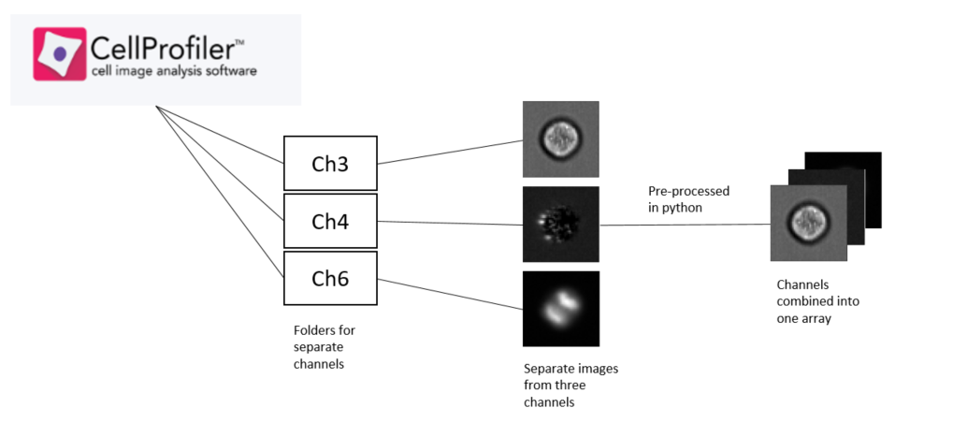

****Figure 21. Dataflow for pre-processing the dataset****

## 4.2. Convolutional Neural Network Design

The design for convolutional neural networks tends to be very varied in such a way that one approach for one dataset may produce good results for that dataset, however may produce underwhelming results for other datasets. There is no generalised one fits all solution for convolutional neural networks.

When choosing the size of a network, the size should be picked to avoid underfitting and overfitting the data. The network size should be large enough so that the network wont underfit the data, however the network size shouldn’t be too large as the network would overfit the data. Because of this a network size of eight layers is chosen. Six of these layers are convolutional layers and the remaining two are fully connected layers. Two convolutional layers are combined before being passed into a max pooling layer, similar to the structure used in VGG Net. The images within the dataset are initially resized to a uniform size of 55x55 before being combined with one another to create an array of size 55x55x2. The reasoning behind initially only using two channels is explained fully in chapter 6. Dropout is applied between the final max pooling layer and fully connected layer, and between the two fully connected layers. Dropout was implemented in the network as it was used to great effect in AlexNet [19]. The base model architecture for this network is shown 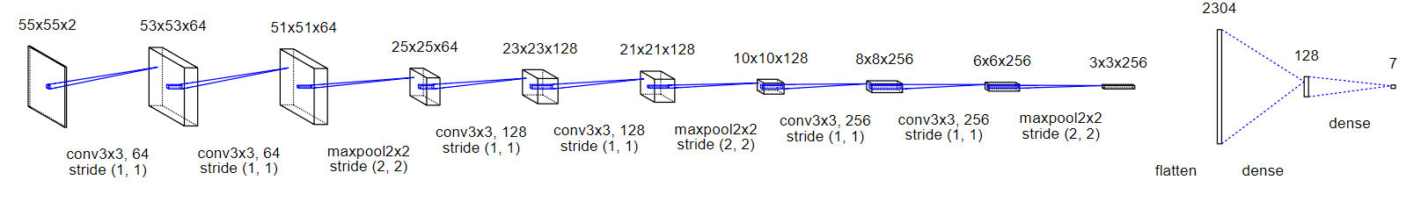in figure 22.

****Figure 22. Architecture for the networks base model****

## 4.3. Choosing Hyper-parameters

The networks performance is mostly impacted by its hyper parameters. Hyper-parameters are set before training the network and can be variables which either determine the networks structure or the way a network is trained. There are several methods for choosing hyper-parameters. These are: manual search, grid search, random search and Bayesian optimization.

Manual search is when personal knowledge about the problem at hand is used to make an educated guess to what hyper-parameters should be used. For example if a network for classifying dogs is to be created, it could use a similar network to one that classified cats as there are several shared features. From this the parameters of the network would be tweaked until a desired result is reached.

Grid search is the most common method for choosing hyper parameters. Similar to manual search In which personal knowledge about the problem at hand is used to make an educated guess on the range of values that hyper-parameters should use. Multiple values at uniform points in the selected ranges are selected and then the network is trained on those values. Another combination of values in the selected ranges are chosen and the network is trained again. This is repeated for all values and the best performing combination is chosen.

Random search. Like grid search a range of values are chosen based on personal knowledge about the problem. However rather than choosing from uniform points in the range, random values are chosen. This is repeated until the desired accuracy is reached.

Bayesian Optimization, works on either of the above approaches, however takes the result given from training the network to decide how to adjust the hyper parameters. For example if a network performs well with one combination of hyper parameters but poor with another combination then the next set of hyper parameters suggested will be more similar to the higher performing combination. This method in theory should be more efficient than others due to the algorithm having an understanding of what hyper parameters have a positive impact on the result.

## 4.4. Types of hyper-parameters

The hyper-parameters which determine how a network is trained include: number of epochs, batch size and the number of splits for k-fold validation.

The number of epochs are the number of times the model is trained on the training data. Having too few epochs would potentially mean that the network may not learn enough from the data and so will have a poor accuracy when classifying the test data. Having too many epochs however will increase training times. The accuracy tends to converge after a certain number of epochs and so the remaining epochs will be pointless and just waste resources. Too many epochs will also cause the network to overfit, meaning the network is learning to memorise the training set rather than learning the features from it. A value of 15 is chosen as the base point for this network. There is a method called early stopping which will be attempted to implement. Early stopping is the network is stopped from training when it reaches a convergence in accuracy. With backwards propagation the network increases in accuracy until it reaches its optimum value. After that point however the network will begin to overfit. There are several approaches when it comes to early stopping. The basic idea is to periodically feed the test set into the network, per say every 5th epoch and compare the results for each of these test sets. When the error is higher than it was the last time it was checked training is stopped. However the error can have multiple local minimums and so may have the lowest error after an initial rise on the graph and so this needs to be kept in consideration.

Batch size is the number of examples from the training data that is fed into the network at one time. A value that is a power of 2 should be used to improve GPU performance. This is because CPU and GPU architectures organise their memory in powers of 2. Values such as 32, or 64 and 128 are quite commonly used so one of these values will be used. This hyper parameter should in theory have little effect on the test performance, however it has a big effect on the training time [30]. Having a batch size that’s too small will increase training time. Whereas having larger batches will decreases training time, however depends upon the amount of GPU memory available.

The hyper-parameters which determine a networks structure include: the number/size of layers, the use of dropout etc.

The number of layers are in a network can have a huge influence on the networks performance. One approach when deciding the number of layers in a network is to ‘just keep adding layers until the test error rate does not improve anymore’ – Yoshua Bengio [31]. So this approach will be carried when implementing the neural network. The only issue here however is that as more layers are added the time to train the network increases. This would mean that a trade of will have to be achieved between accuracy and training time.

Another hyper parameter which can influence results is dropout. Dropout is a form of regularisation which helps to prevent overfitting. A wide range of dropout layers/size of dropout will be used when implementing the neural network.

## 4.5. Dealing with overfitting

One point that needs to be in consideration for this network, is that due to the large amount of images in the dataset, the network will most likely overfit and so some methods to deal with overfitting need to be implemented.

A major issue with this dataset is that some classes are underrepresented and so there is quite a class imbalance. The stages of the cell cycle in Mitosis such as anaphase, metaphase and telophase only have 14, 68, 27 instances respectively, whereas the interphase stages have over 7000 instances each. There are a number of approaches when dealing with class imbalances.

The most obvious approach would be to collect more data, however due to the nature of the cell cycle, the stages in mitosis only last a fraction of the time of others, meaning that it’s harder to collect images for those stages. [1]

**One common method is to under sample the data. This involves reducing the number of samples in the overpopulated classes. However this can discard a lot of the data that the network can learn features from. Under sampling is not a method that will be used in this project. This is because after having contacting one of the authors from ‘Reconstructing cell cycle and disease progression using deep learning’ [1], Niklas Köhler, he suggested that unless the network is dealing with a huge dataset which would cause computational problems, having more data is nearly always better for the network to learn from.**

One method that’s quite the opposite of under sampling is to oversample the data. This can involve some form of image augmentation such as flipping the image, cropping parts of the image, and rotating images etc. Some image augmentation techniques would be useful for the single-cell images, such as horizontal and vertical flips as they keep the original details of the image intact. Others may not be beneficial for the single-cell images. For example by cropping random parts of the image, the crop may take away the most important part of the image, meaning the network would have to learn a new representation for that class. Oversampling has been shown to be an effective method to reduce the class imbalance. Oversampling can be expected to increase the efficiency in training. For example with oversampling the network could achieved the same accuracy as without oversampling with a 1/3rd of the iterations.

## 4.6. Visualisation techniques

### 4.6.1. t-Distributed stochastic Neighbourhood embedding (t-SNE)

t-Distributed Stochastic Neighbour Embedding (t-SNE) is an unsupervised machine learning technique for dimensionality reduction that’s useful for the visualization of highly dimensional datasets. [32]

Dimensionality reduction is a way to reduce the highly dimensional features that we would find in the fully connected layers into smaller dimensions, while still keeping the vital attributes of each image. If the important details of each image are retained then these details are able to be plotted on a graph to show how similar each image is to one another. This graph then sows how some images share certain features. Perplexity is the main parameter that controls the fitting of the reduced dataset. It’s considered to be the number of nearest neighbours a point has. A low perplexity, would mean a local scale with each point having more nearest neighbours whereas a high perplexity would mean a global scale with each point having fewer nearest neighbours. Figure 23 shows t-SNE used to visualise the MNIST dataset, which is a collection of handwritten digits.

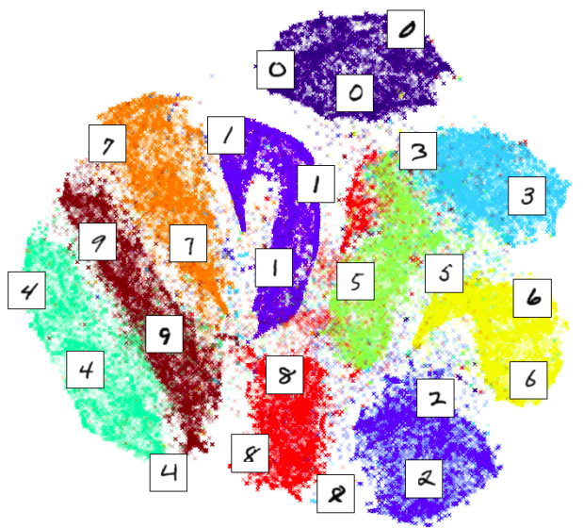

****Figure 23 . t-SNE representation of the base model [33]****

### 4.6.2. Dense/Convolutional Layer Visualization

Keras-Vis is a high level toolkit for visualizing trained neural networks built from Keras [33]. It can be used to visualise the convolutional filters and fully-connected layer representations of classes. These layers can be visualised by filter visualisation.

Filter visualisation for a certain layer involves using a grey image with some noise and calculating the gradient of that image with regard to a loss function which maximises that selected filters activation. The output from this can then be plotted. Early convolutional layers should show simple features, whereas later filters should show more complex features. Figure 24 shows convolutional filter visualisation in regards to the VGG16 model which was used to classify the ImageNet dataset. The dense layer can also be visualised to see what input maximises that filters activation. Figure 25 shows the dense layer visualisation for the VGG16 model.

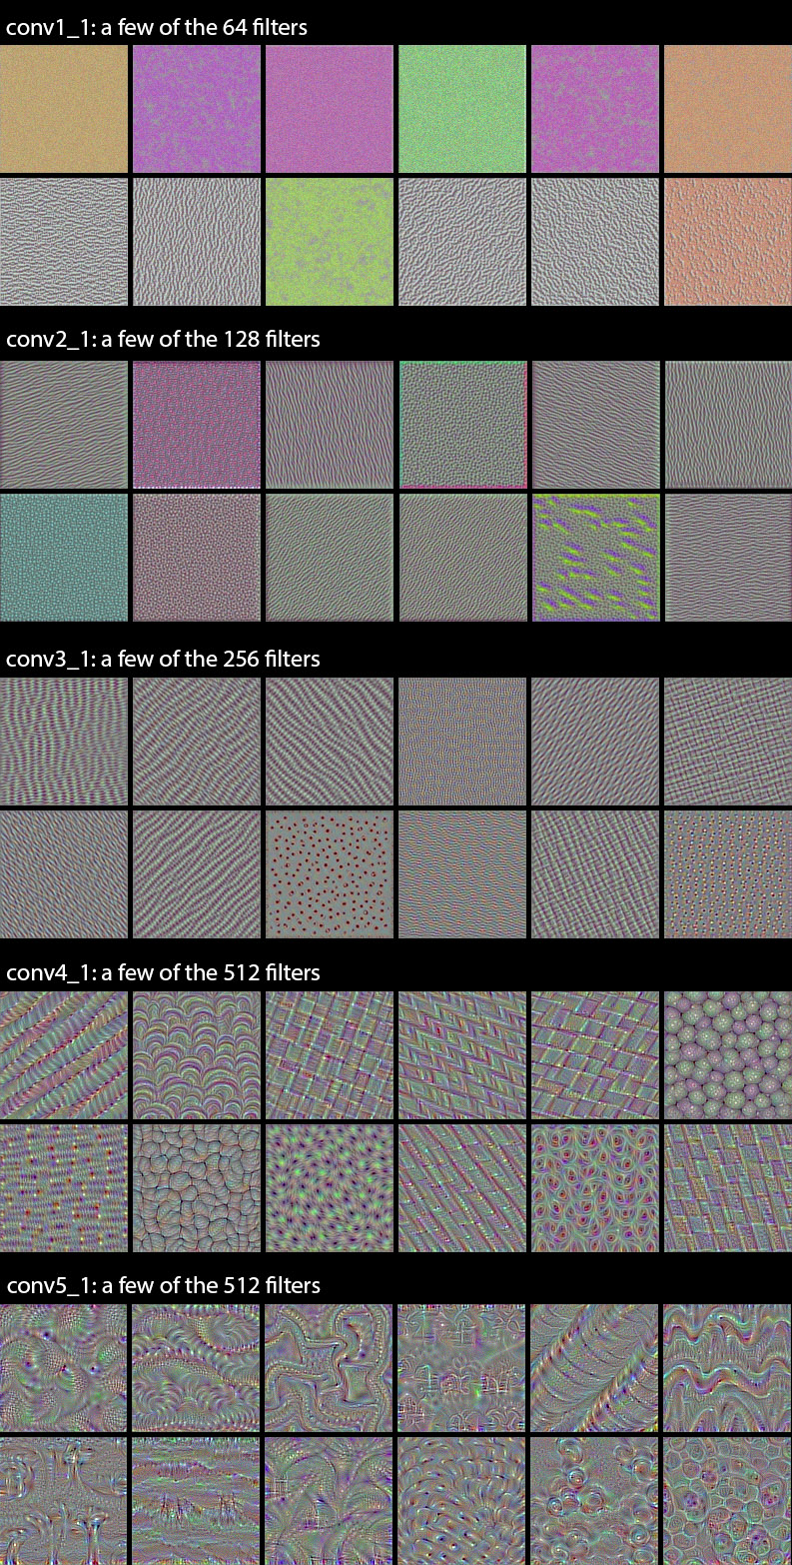

****Figure 24. Filter representations of convolutional layers from VGG16 [34]****

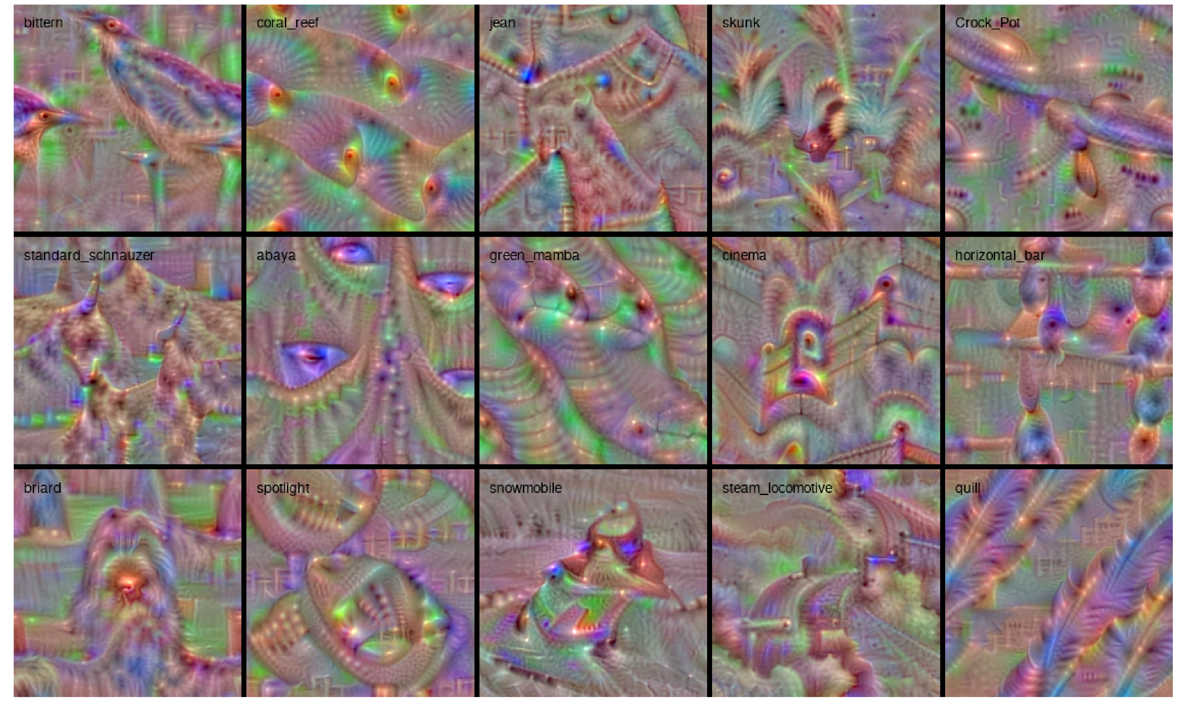

****Figure 25. Filter representations of dense layers from VGG16 [34]****

This method will show a deeper understanding into what certain layers of a convolutional network learn. Showing visualisations from concurrent layers will show a feature hierarchy which displays how simple features are combined to create more complex features.

# Chapter 5 – System implementation

This chapter covers the implementation of the chosen architecture for this project. It shows the technologies used for this project alongside a performance comparison between the available CPU and GPU. It also shows the steps undertook to make the single cell cytometry dataset feasible to use within the chosen open source deep learning framework. Extracts of code will be shown to help clarify some details.

## 5.1. Technologies used

Keras and Python are the two key pieces of technologies that enabled the development of this project. Python is an open source programming language which was designed with speed in mind. Python also comes with a wide range of scientific libraries which make it easy to experiment and prototype new ideas with.

Keras is an open source neural network API, which is capable of running on top of TensorFlow or Theano. Keras is a neural network library which uses modularity to provide a user friendly experience. The API is designed to intuitive to use and enables its users to quickly create complex models with little programming experience.

Scikit-learn is a scientific library for python that contains efficient tools for data mining and data analysis. Its main focus is on modelling data. The two groups of models used in this project are the cross validation and unsupervised learning models. From the cross validation models the k-fold cross validator was used to split the dataset. From the unsupervised learning models t-SNE was used to model the dataset.

Training was completed on a NVIDIA GeForce 840m GPU which has 2GB of dedicated Ram. This GPU is CUDA-enabled, meaning that it can be used for general purpose processing. This GPU proved to be adequate for the implementation and testing of the convolutional neural network.

## 5.2. Usage of a GPU

Since deep learning networks tend to be highly computational a GPU is preferred to a CPU. The examples provided by Keras will be used for experimentation in which an Intel i5 is compared against an NVIDIA GeForce 840m. For the cifar10 CNN 10 epochs were carried out for an accuracy of 0.634 and a loss of 0.893. The results between the CPU and GPU were nearly identical. The speed however varied. The GPU achieved that result in 560 seconds, or an average of 56 seconds per epoch. The CPU however achieved this in 3935 seconds, on an average of 393.5 second per epoch. The GPU is almost six times faster for this example and so will be used when implementing the neural network for this project.

## 5.3 Model architecture

****The chosen base architecture for the network is described in the design section. It contains eight layers, six of which are convolutional and the reaming two are fully connected. The architecture is shown again below:

****Figure 27. Architecture for the networks base model****

The code for this model is shown below:

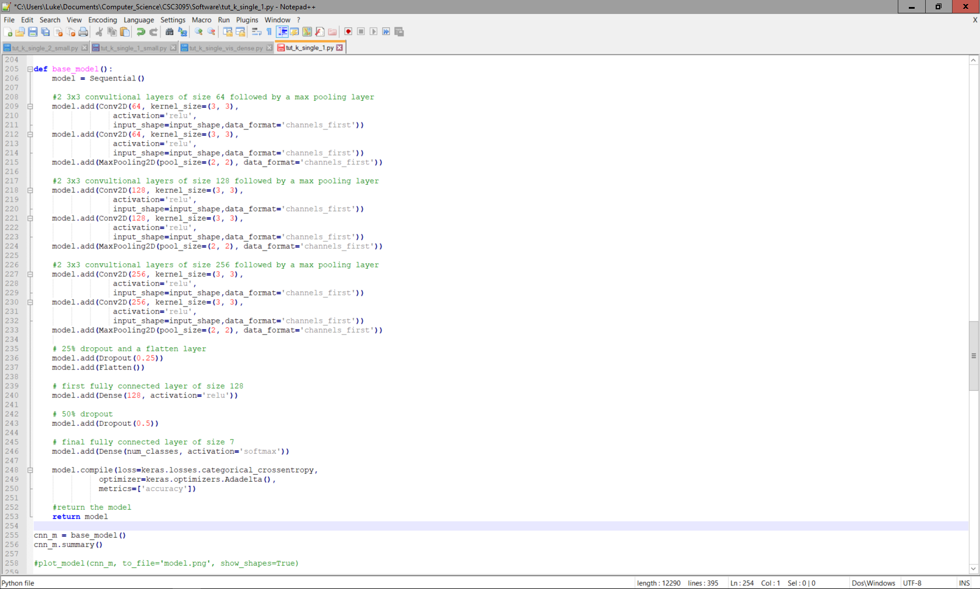

****Figure 28. Code to create the base model****

This network contains over a million parameters. Because of the large number of parameters and the large size of the dataset, the model above took 4 and a half hours to run on an Nvidia GeForce 840m. Because of the length of time taken here, it would be infeasible to experiment solely on the full dataset. To enable more experiments to take place with a wide range of various hyper-parameters, a smaller subset was created from the full dataset which contained a more equal class balance and a total of 510 cells.

## 5.4. Preparing the dataset

As mentioned in the methodology section k-fold validation will be used to validate this model. The code is provided below:

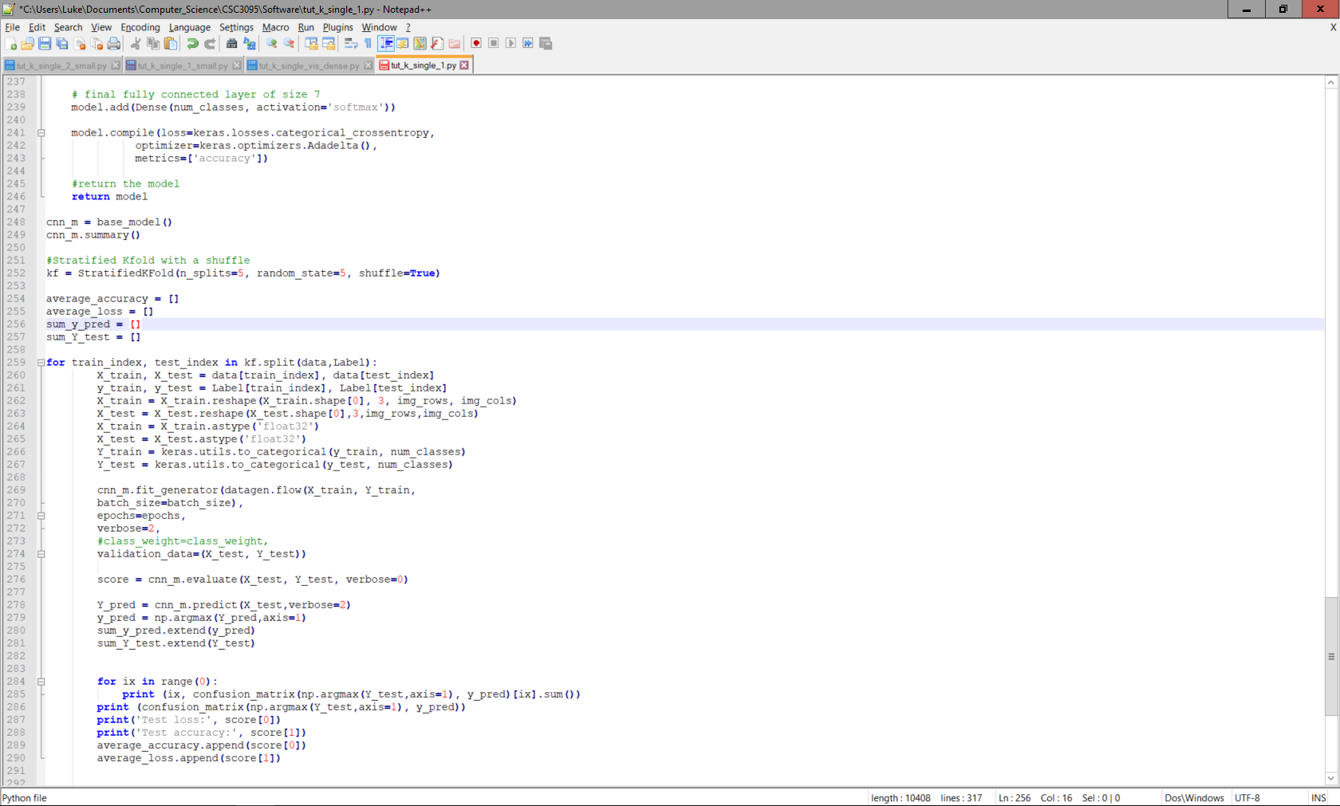

****Figure 29. Code to split the dataset****

The number of splits in this case is five, meaning that the dataset is split into five equal parts. This means that for each time the network runs it is fed a training set which contains 80% of the original dataset and a test set of 20%. The network runs five times with this dataset and then outputs the overall confusion matrix which combines the previous five matrices along with the average accuracy and loss of this network. This k-fold was shuffled since the data is ordered by class. Without shuffling the network would overfit as it would initially only learn to classify the classes that appear first in the data and so would not be able to correctly classify classes that appear later in the data. By shuffling the data the network receives are more balanced distribution of classes.

# Chapter 6 - Testing and Evaluation

This section will show the performances of each iteration of my convolutional neural network and compare the performances between each iteration. For each iteration the changes made for that iteration will be described. After the final iteration this papers final model will be decided and the results from this model will be compared to the results from a recent paper [1]. The final models convolutional layers and dense layers will be visualised along with a t-SNE representation of the data.

## 6.1. Iterative testing

The base model has been described in the Design and implementation section.

The smaller dataset will be used for the first set of tests. The basic hyper-parameters used for the smaller dataset in this network were:

* Batch size = 32
* Number of epochs = 15
* Number of K-folds = 5

The first few iterations will be experimenting with various ways of inputting the data into the network and a experimenting with range of hyper-parameters.

**Iteration 1**

The input images were resized to a uniform size of 55x55. This network performed poorly on the small dataset and achieved an accuracy of 19.6%. The network didn’t learn anything and predicted the same class for the entire dataset.

The issue with this first run is that the data wasn’t normalised. As there are 2 different channels used in this dataset the pixel values are widely ranged. Normalising data is an important step for preparing data to enter a network. One way to normalise data is to divide the data by the max pixel value from that data, this ensures a pixel range of 0-1. The method chosen for this network was to take the mean away from the data and divide by its standard deviation. This centres the mean at 0, helping with issues such as exploding or disappearing gradients.

**Iteration 2 and 3**

There are two options for normalising images. To normalise per channel, or to normalise per image. Since the dataset being used is single cell cytometry data, the channels will have very different representations of the cell. This should mean that normalising per channel will have superior results.

Run 2 normalised images per channel and achieved an accuracy of 71.62% and a loss of 0.773.

Run 3 normalised images per image and achieved an accuracy of 57.03% and a loss of 1.04.

These results confirm that normalising this dataset per channel is the superior method and so will be used in future tests.

**Iteration 4, 5 and 6**

Before changing hyper-parameters in the network, it’s important to ensure that the input to it is correctly pre-processed. One issue with the above model is that the dataset is being resized to a uniform size. This may be okay for some datasets, however it may negatively affect the performance for the single cell cytometry dataset. This is because there are some size related information between cells [1] and it’s important to preserve this information for the network. One way to make certain that the scale of the images are preserved is to add padding. Padding is a way of enlarging an image to fit a certain size. A size of 66x66 is chosen as that is the maximum width/height of a cell from the dataset. A colour is required to pad the image with.

Run 4 used black padding and achieved an accuracy of 70.00% and a loss of 0.839

Run 5 used white padding and achieved an accuracy of 76.06% and a loss of 0.67

Run 6 used a pixel value from the border of the image and used that to pad the image. It achieved an accuracy of 79.22% and a loss of 0.636.

These results show that padding images, compared to resizing images is a superior way to transform images to a uniform size. Run 6 showed that padding the image with a value from its border is superior to padding It with either black or white and so will be used in future tests. The issues with padding with a different colour to the image is that the network needs to learn that the padding has no significance in classifying cells, however the results above show that the network struggled to learn this. This padding just added extra complexity which worsened results.

**Iteration**

At this stage of the testing, the network is producing some somewhat impressive results, however the third flourescent channel hasn’t been implemented in this network yet. The researchers from ‘Reconstructing cell cycle and disease progression using deep learning’ [1] only used two channels in there neural network. This is because the fluorescent channel can affect the biological processes under study. Despite these potential effects the fluorescent channels were adequate enough to classify cells. The fluorescent channels contain additional information about the dataset that is not present in the brightfield and darkfield channels and so will be implemented into the network to compare performance.

Run 7 uses a fluorescence channel in addition to the already used brightfield and darkfield channels. It achieved an accuracy of 82.54% and a loss of 0.480.

This result shows that by adding the fluorescence channel into the network along with the brightfield and darkfield the network achieves a higher accuracy. This network appears to converge later than the previous network and so with more epochs and data should increase its accuracy further.

**Iteration 8**

One parameter which can have a large impact on the accuracy of a network is the size of the fully connected layers. The model above used a size of 128. A fully connected layer of size 512 was used in this model and achieved an accuracy of 85.10% and a loss of 0.464.

Increasing the size of this layer seems to of had a huge impact on the classification accuracy of the metaphase cells. This model will be used for future experiments.

From here on out the remaining experiments will be completed on the larger dataset. The following hyper-parameters will be used:

* Batch size = 128
* Number of epochs = 15
* Number of K-folds = 5

The architecture for this final model is as follows:

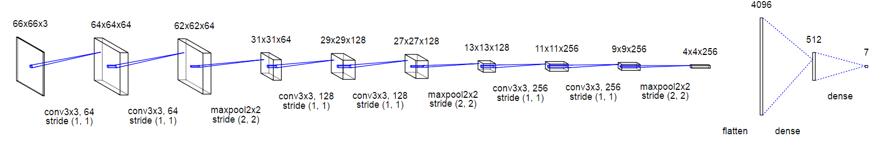

****Figure 30. Architecture for the final model of this network****

**Iteration 9**

This experiment will be a repeat of the above model to see the results of training on a more unbalanced and larger dataset. This model achieved an accuracy of 96.94 % and a loss of 0.0964. The confusion matrices are shown in figure 31

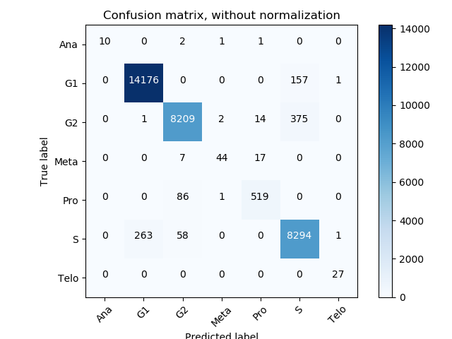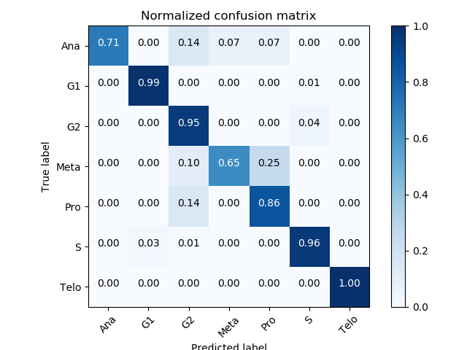

****Figure 31. Confusion Matrices from iteration 9****

**Iteration 10**

This final experiment will use the same architecture as above but implement two last methods which aim to help overfitting. Class weights and image augmentation will be used. Class weights are a weighting corresponding the number of each class in the dataset. Larger values indicate that that class is under-represented. These class weights tell the network to pay more attention to under-represented classes. Image augmentation was also used to increase the number of samples the network sees. The augmentations applied will be horizontal flips and vertical flips. These techniques were chosen as they don’t alter the shape, size or ratio of a cell in anyway. These flips practically increase the dataset four-fold as shown in figure 32.

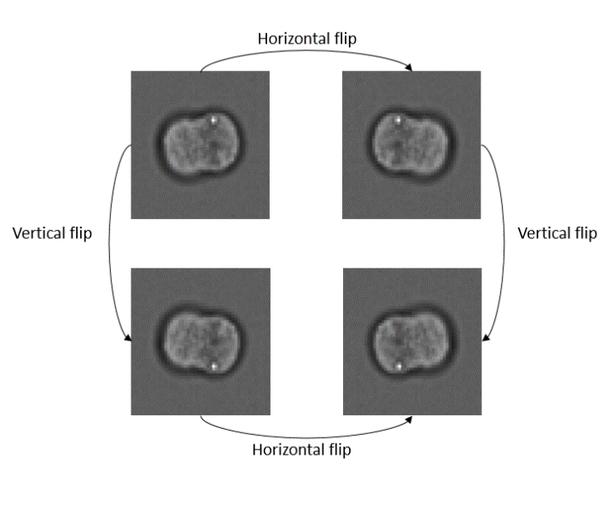

****Figure 32. The effect of image augmentation****

This model achieved an accuracy of 94.83% and a loss of 0.132. These results were disappointing and showed that these methods to reduce overfitting somehow actually increased overfitting for this particular dataset.

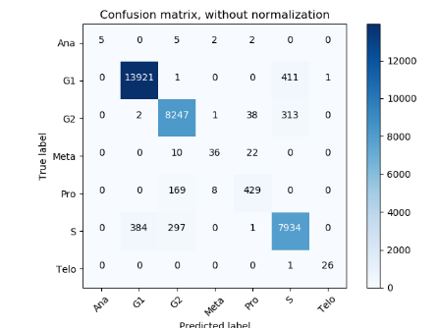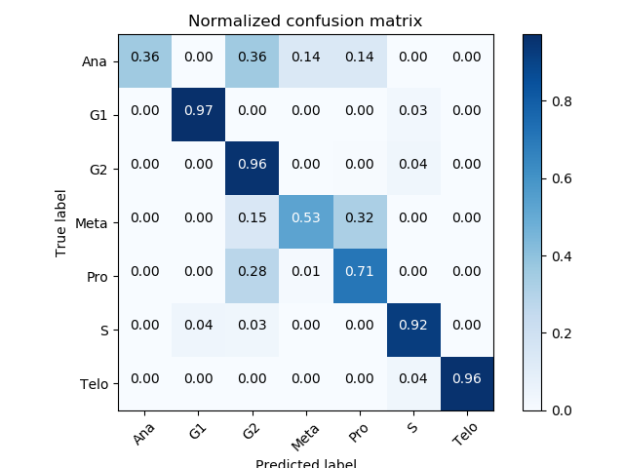

****Figure 33. Confusion Matrices from iteration 10****



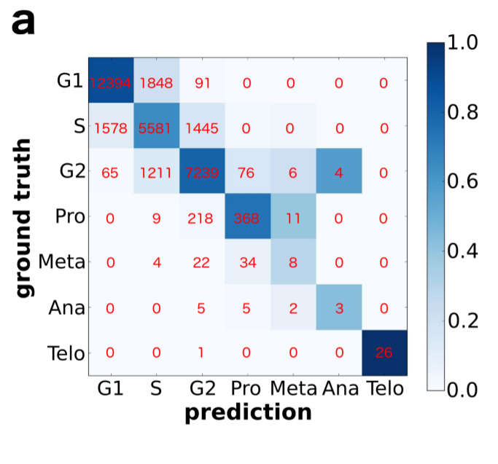****Figure 34. Confusion Matrix researchers achieved - Left [1]****

****Figure 31. Confusion Matrices from iteration 9 – right****

The highest performing convolutional neural network produced in this project achieved an accuracy of 96.94% when classifying the seven cell cycle phases. The network took five hours to run. Researchers achieved an accuracy of 79.40%. The network developed in this project learned lower-represented classes with a higher precision. For comparison, the network researchers created only correctly classified 3 cells in anaphase and 8 cells in metaphase, whereas the network developed in this project correctly classified 10 cells in anaphase and 44 cells in metaphase. This precision for the underrepresented cells is also found in classifying cells in the interphase stage. There is a drastic reduce in the number of false positives in this stage.

## 6.2. t-SNE for unsupervised machine learning

The full dataset was used for unsupervised machine learning with t-SNE. When combining different cytometry channels the resulting graph was a jumbled mess with no visual correlations. When applied to the brightfield channel however produced some somewhat impressive results in that the cell cycle was nearly recreated. Figure 35 shows the graph produced from the brightfield channel.

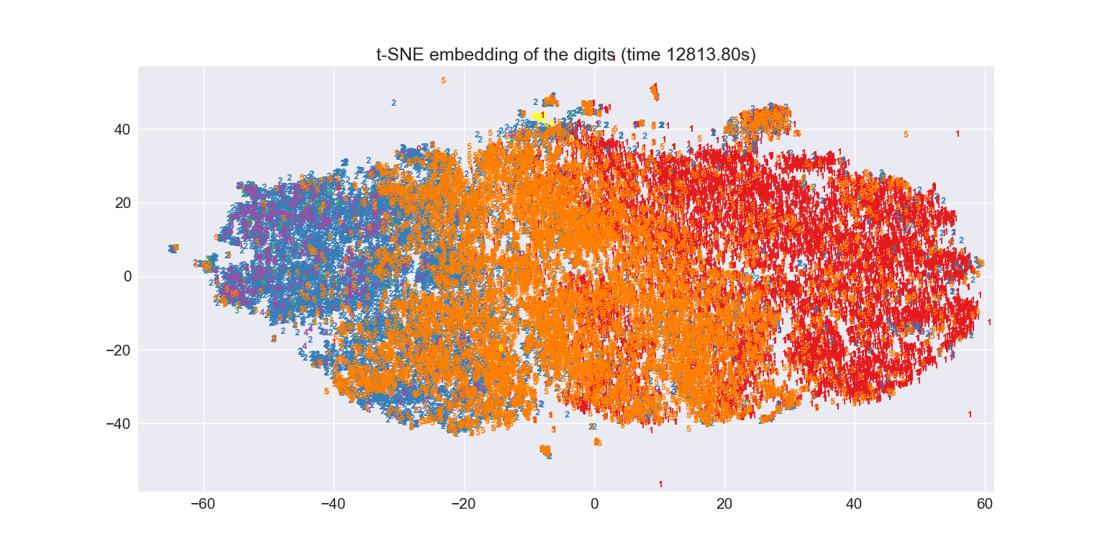

|  |  |
| --- | --- |
| **Colour/Label** | **Phase** |
| **Red/1** | **G1** |
| **Orange/5** | **S** |
| **Blue/2** | **G2** |
| **Purple/4** | **Prophase** |
| **Green/3** | **Metaphase** |
| **Red/0** | **Anaphase** |
| **Yellow/6** | **Telophase** |

****Figure 35. t-SNE representation of the cell cycle bases on images from brightfield channel (ch3) [1]****

From this graph it’s clear to see three groups of distinct cells: G1 (Red), S (Orange) and G2 (Blue). These cells all belong in the interphase stage of the cell cycle and so are the similar cells. t-SNE has recognised these similarities and plotted these cells close to one another. The ordering of these cells is also correct in that the cells at the start of the interphase (G1) are plotted to the right-most side of the graph and then the following two stages (S and G2) are plotted to the left, before mitotic cells appear. The first two stages of mitosis (Prophase and Metaphase) appear to the left of the G2 cells in the correct order. The final two stages can be seen circled on the graph. Perhaps the reasoning behind such a strange placement is that these two cell cycle phases are perhaps the most different to any other stages. Therefore they will naturally be plotted away from other phases.

## 6.3. Dense layer visualisation

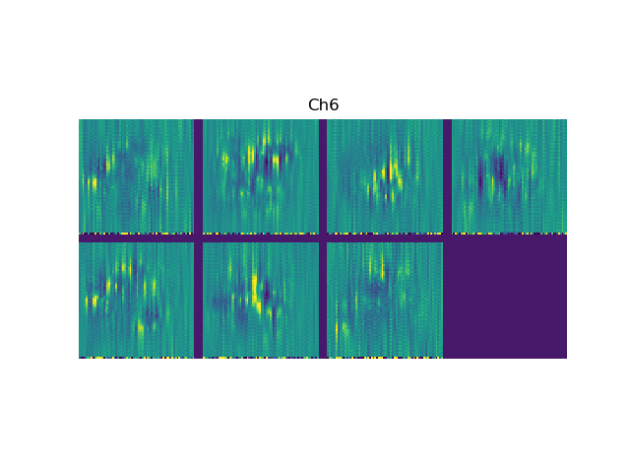The final model used in this project produces some questionable results for the dense and convolutional layer visualisations. The dense layer visualisations for the darkfield image are shown in figure 36. The cells are labelled from left to right as: Ana, G1, G2, Meta, Pro and Telo.

****Figure 36. Darkfield Dense layer visualizations of the cell cycle classes****

These visualisations don’t really show any insights into what the network is learning to classify for the single cell data. An older model, which happened to be trained on two channels produced some recognisable visualisations. Figure 37 contains an older iteration of the neural network, which was also trained on the smaller dataset, showing dense layer visualisations from the darkfield channel.

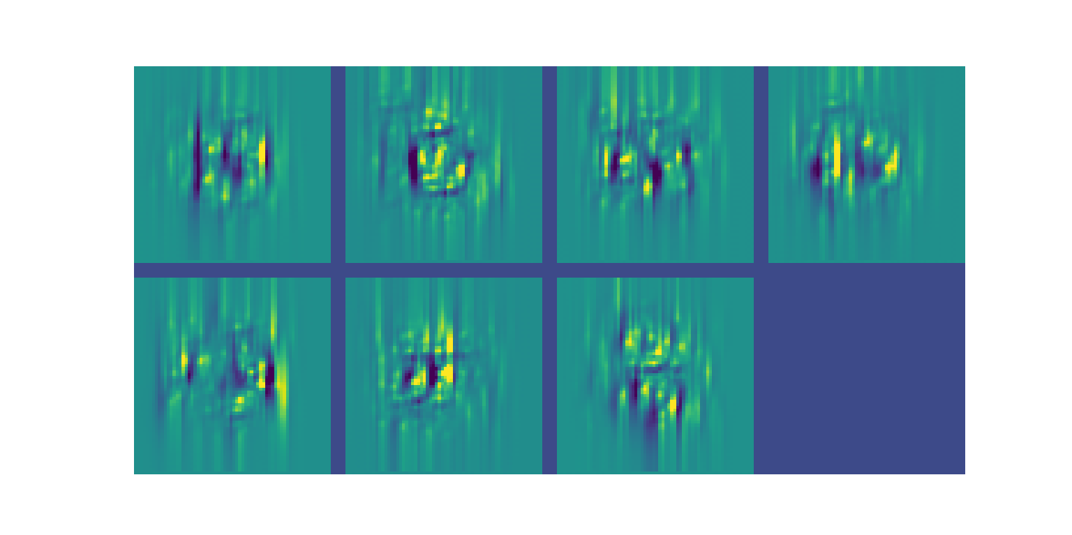

****Figure 37. Darkfield Dense layer visualizations of the cell cycle classes****

From this image however it’s quite clear that the final dense layer has learned to classify telophase cells from the appearance of an emerging cell. The other cell stages are still perhaps hard to distinguish based on these dense layer visualisations.

One possible reasoning behind these results is that the different channels of the cell image cytometry data contain data that contain a different range of information. Because of this they can’t correctly be overlapped/combined in the way RGB images are for visualisation. If a dense layer visualisation was wanted for a certain channel then a new network would have to be trained using that single channel.

# Chapter 7 - Conclusion

The original aim of this project was to create deep learning networks that could classify single-cell cytometry data. A convolutional neural network was developed in the paper which classified such cytometry data to an accuracy of …. This improved upon the results obtained by a recent paper [1] who achieved an accuracy of… This performance increase could be due to a number of factors, such as by normalising the data so that the mean is zero centred or perhaps the addition of the fluorescence channel.

The network exceed my expectations and classified the unbalanced dataset effectively. One area the network could improve on is classifying the underrepresent classes, such as Anaphase and Metaphase. Various up sampling methods were used in this project, however they decreased the networks performance. Perhaps some more extended fine tuning would improve on this.

One aim which perhaps could have been more solidly met was to recognize novel groups of cells with unsupervised learning. t-SNE was used to cluster cells into similarities, but was unable to cluster novel cells, such as dead cells. This could have been due to the fact that the entire dataset was used on t-SNE, meaning that these cells appear harder to find with such a large amount of cells present.

If more time was possible I would have liked to have implement a GUI, which would have simplified the process of inputting data into the network, this would be of use if future datasets are to be used on this network. I would of also of liked to use more visualisation techniques to truly see how the network is learning to classify the dataset.

Perhaps the biggest limiting factor for this project was the power of my GPU. The largest network ran took five hours to run. This is a long time to wait between experiments, and without constant examination would often be a waste of time.

## References

**[1] Eulenber P. et al. (2016). Reconstructing cell cycle and disease progression using deep learning.**

**[2] Filby, A. and P.ouston, J. (2017). Imaging cytometry: Automated morphology and feature extraction.**

**[3] Blasi, T. et al. (2016). Label-free cell cycle analysis for high-throughput imaging flow cytometry. Nature Communications.**

**[4] Hennig, H. et al. (2017). An open-source solution for advanced imaging flow cytometry data analysis using machine learning.**

**[5] Van Valen, D. et al. (2016). Deep Learning Automates the Quantitative Analysis of Individual Cells in Live-Cell Imaging Experiments. PLOS Computational Biology.**

**[6] Mitchell, T. (1997). Machine Learning.**

**[7] Wang, S. (2003). Artificial Neural Network.**

**[8] [online] Available at: https://towardsdatascience.com/what-the-hell-is-perceptron-626217814f53**

**[9] Csáji, B. (2001). Approximation with Artificial Neural Networks.**

**[10] Deng, L., Dong, Y. (2014). Deep Learning: Methods and Applications.**

**[11] Silver, D. et al(2017). Mastering the game of Go without human knowledge. [online] Available at:** [**https://deepmind.com/documents/119/agz_unformatted_nature.pdf**](https://deepmind.com/documents/119/agz_unformatted_nature.pdf)**.**

**[12] [online] Available at:** [**https://www.cc.gatech.edu/~san37/post/dlhc-cnn/**](https://www.cc.gatech.edu/~san37/post/dlhc-cnn/)

**[13] Angermueller, C., Pärnamaa, T., Parts, L. and Stegle, O. (2016). Deep learning for computational biology.**

**[14] [online] Available at: https://www.analyticsvidhya.com/blog/2017/04/comparison-between-deep-learning-machine-learning/**

**[15] [online] Available at:** [**https://cloud.google.com/vision/**](https://cloud.google.com/vision/)

**[16] [online] Available at:** [**https://arxiv.org/pdf/1702.07800.pdf**](https://arxiv.org/pdf/1702.07800.pdf)

**[17] [online] Available at:** [**https://en.wikipedia.org/wiki/Sigmoid_function**](https://en.wikipedia.org/wiki/Sigmoid_function)

**[18] [online] Available at: https://towardsdatascience.com/activation-functions-and-its-types-which-is-better-a9a5310cc8f**

**[19] Krizhevsky, A., Sutskever, I. and Hinton, G. (2017). ImageNet classification with deep convolutional neural networks. Communications of the ACM.**

**[20] [online] Available at: https://en.wikipedia.org/wiki/Convolutional_neural_network#/media/File:Max_pooling.png**

**[21] Srivastava, N. et al. (2014). Dropout: A Simple Way to Prevent Neural Networks from Overfitting.**

**[22] Deng, J. et al. (2010). ImageNet: Constructing a large-scale image database. Journal of Vision.**

**[23] D. Zeiler, M. and Fegus, R. (2013). Visualizing and Understanding Convolutional Networks.**

**[24] [online] Available at:** [**https://www.codesofinterest.com/p/build-deeper.html**](https://www.codesofinterest.com/p/build-deeper.html)

**[25] Szegedy, C. et al. (2014). Going Deeper with Convolutions.**

**[26] Russakovsky, O., Deng, J. and Su, H., et al. (2015). ImageNet Large Scale Visual Recognition Challenge.**

**[27] What I learned from competing against a ConvNet on ImageNet. [online] Available at: http://karpathy.github.io/2014/09/02/what-i-learned-from-competing-against-a-convnet-on-imagenet/**

**[28] [online] Available at: https://towardsdatascience.com/train-test-split-and-cross-validation-in-python-80b61beca4b6**

**[29] [online] Available at:** [**http://cellprofiler.org/imagingflowcytometry/IFC_label_free.html**](http://cellprofiler.org/imagingflowcytometry/IFC_label_free.html)

**[30] Bengio, Y. (2012). Practical Recommendations for Gradient-Based Training of Deep Architectures.**

**[31] [online] Available at: https://www.quora.com/Artificial-Neural-Networks/Artificial-Neural-Networks-How-can-I-estimate-the-number-of-neurons-and-layers/answer/Yoshua-Bengio?share=7b58dc3b&srid=hqJd**

**[32] [online] Available at: https://lvdmaaten.github.io/tsne**

**[33] [online] Available at:** [**https://nlml.github.io/in-raw-numpy/in-raw-numpy-t-sne/**](https://nlml.github.io/in-raw-numpy/in-raw-numpy-t-sne/)

**[34] [online] Available at:** [**https://raghakot.github.io/keras-vis/**](https://raghakot.github.io/keras-vis/)**].**